**TP – 17/18**

**A Project Report On**

**Salon At Door-Step**

**(By SEMESTER-VI of III Year M.Sc. (2017-18))**

**Kushal Gohel : 3017**

**Jolly Makwana : 3031**

**Dixit Nagar : 3037**

**Name of Company**: TRENDZ the unisex saloon

**Date of Submission**: 28-April-2018

**Submitted To**



K. S. School of Business Management

M.Sc. – Computer Application and Information Technology

**Acknowledgement**

In performing our project, we had to take the help and guideline of some respected persons, who deserve our greatest gratitude. The completion of this project gives us much pleasure. We would like to show our gratitude **Mr. Arjun Sharma (Founder of TRENDZ), all teaching faculty of K.S. School of Business Management** for giving us a good guideline for assignment throughout numerous consultations. We would also like to expand our deepest gratitude to all those who have directly and indirectly guided us in writing this assignment.

*I*n addition, a thank you to project guide **Dr. Nandita Goswami**, who introduced us to the Methodology of work, and whose passion for the “underlying structures” had lasting effect. Many people, especially our **classmates** and **team members** itself, have made valuable comment suggestions on this proposal which gave us an inspiration to improve our project. We thank all the people for their help directly and indirectly to complete our project.

**INDEX**

1. INTRODUCTION

**1.1 ORGANIZATION PROFILE5**

**1.2 SYSTEM DETAIL5**

1.2.1 EXISTING SYSTEM5

1.2.2 PROPOSED SYSTEM5

**1.3 SCOPE OF SYSTEM6**

**1.4 OBJECTIVES6**

2. PROPOSED SYSTEM REQUIREMENT GATHERING

**2.1 STAKEHOLDER OF SYSTEM7**

**2.2 REQUIREMENT GATHERING TECHNIQUE USED8**

**2.3 CONSOLIDATED LIST OF REQUIREMENT9**

**2.4 PROJECT DEFINITION9**

3. SYSTEM MANAGEMENT AND PLANNING

**3.1 FEASIBILITY STUDY11**

3.1.1. TECHNICAL11

3.1.2. ECONOMIC11

3.1.3. OPERATIONAL11

**3.2 HARDWARE-SOFTWARE REQUIREMENT12**

**3.3 SYSTEM PLANNING13**

3.3.1 WORK BREAKDOWN STRUCTURE13

3.3.2 GANTT CHART14

**3.4 PROCESS MODEL15**

4. SYSTEM ANALYSIS AND DESIGN

**4.1 UML(UNIFIED MODELING LANGUAGE)/DFD18**

**4.2 SYSTEM FLOW DIAGRAM27**

**4.3 DATA DICTIONARY31**

**4.4 USER INTERFACE39**

**4.5 SYSTEM NAVIGATION57**

5. INPUT/OUTPUT DESIGN

6. TESTING

7. SUMMARY

**7.1 LIMITATIONS76**

**7.2 FUTURE SCOPE76**

BIBLIOGRAPHY

**CHAPTER: 1 INTRODUCTION**

This chapter gives introduction about organization, existing system, proposed system and it also helps to know its scope and objectives.

* 1. **ORGANIZATION PROFILE**

NAME: TRENDZ the unisex saloon

ADDRESS: Shop no.14, Chanakya Plaza, New C G Road, Chandkheda, Ahmadabad-382424.

Owner: ARJUN SHARMA

* The owner, Arjun Sharma is providing services from past 15 years and now he is going to open his own salon “TRENDZ”...
* His motto is that the services offered not only to provide a valuable beauty experience, but that they also bring a sense of community and offer best services.
* He works with staff members to improve performance and ensure quality service while maintaining cleanliness and customer satisfaction. In cooperation with artist he also analyzes artists’ records, requisitions supplies and assist in resolving customers complaints.

**1.2 SYSTEM DETAILS**

**1.2.1 EXISTING SYSTEM**

* This is a salon which works since 15 years.
* It is one of the reputed organizations where people frequently visit for all kind of salon services. It is a unisex salon which provides services for both male and female. They have numerous consumers. Here the total process is handled manually. But the problem we observed is that artists are available for specific time duration so that customer cannot choose their suitable time. Due to this various problems arises such as they are not able to serve all the customers.
* The current handling of a salon is done by a receptionist who would take appointments on phone calls or on place. But he is unable to do handle all appointments on phone calls and on place simultaneously. Thus there is a poor time management. Also he is not able to handle advance appointments as well as postponed appointments. Management of salon is totally manually. They take appointments manually & payment records are hand-written.
* We saw that there are more number of customers grouped at the same time and salon get stuck by customers so that more number of customers has to wait or they leave the salon.
* There are also job persons who can’t wait in a queue and have busy schedule so they need such type of facilities.
* Because of hurry, sometimes customers not satisfied with the services. That’s why number of customers are reduced.
* Missed appointments by clients are an ongoing issue in salons & spas.

**1.2.2 PROPOSED SYSTEM**

* Salon At door-Step helps you make better business decisions using near real-time, cloud-based point of sale salon business tools that take every part of your business and salon culture to the next level.
* He always wishes if we had one for ourselves too.... Now here is the opportunity to get a complete professional salon service at your doorstep.
* Their motto is to provide all sorts of exclusive and exotic beauty and hair treatment at the door-step, so that every customer (Men and Women) can enjoy the services in their comfort zone and time.
* He provides people with reliable and soothing salon like experience at their home.
* Professional well versed in various beauty treatments will be made available at door-step for glamorous make over.
* He will provide beauty treatments such as Hair Spa, Threading, Facial, Bleach, DeTan, Waxing, Threading, Manicure and Pedicure with online booking.
* **Scheduling** is one of the main reasons why people are looking for doorstep salon. Scheduling allows you to get rid of the paper based appointment book and ensure you are driving better staffing efficiencies.
* Through the use of *E-MAIL APPOINTMENT REMINDERS,* it has been shown to reduce no-shows by up to 70%. This can drive greater profits into any business.
* **Online appointment booking –** more and more clients are using their smart phone to do daily tasks and this includes making salon appointments.
* In fact, according to Deloitte, Indian look at their smart phone 9 billion times a day!!!
* Because of digitization, they require a system which helps to manage their work & expand their business.

**1.3 SCOPE OF SYSTEM**

* Beauty and wellness industry is growing at swift pace in India with new trends evolving in the society.
* The Scope of project can be decided by the services which the system serves to the customer.
* This system meets customers and as well as salon’s requirements. In future, they facilitated with the services and get involved in the planning also.
* Scope refers to the detailed set of deliverables or features of a project.
* Account: This functionality contains Artist’s account information like appointments.
* Feedback: After completion of service, customer can give their review about service.
* Service: They provide services like facial, waxing, manicure, pedicure, bleach, threading, hair services.
* Blog: Customer can write blog on the site.
* Cart: Customer can see their selected services and appointments in the cart.

**1.4 OBJECTIVES**

* To develop a sustainable start-up business, contributing to increased employment of community residents.
* Keeping current client happy.
* We believe in total commitment to the team. The team objective is a guide for us to follow in our services to our clients, support of each other and team growth.
* We believe our system should be utilized in all activities to provide maximum efficiency and effectiveness for clients.
* We commit to managing out time and setting specific goals within that time.

**CH-2 PROPOSED SYSTEM AND REQUIREMENT GATHERING**

This chapter gives overview about system’s stakeholder, technique which used to gather requirement, list of consolidated requirement and project definition.

**2.1 STAKEHOLDER OF PROJECT**

* In all the system some person who directly or indirectly benefited from the system that are known as stakeholders.
* A person, group or organization that has interest or concern in an organization.
* Stakeholders can affect or be affected by the organization's actions, objectives and policies. Some examples of key stakeholders are creditors, directors, employees, government (and its agencies), owners (shareholders), suppliers, unions, and the community from which the business draws its resources.
* Not all stakeholders are equal. A company's customers are entitled to fair trading practices but they are not entitled to the same consideration as the company's employees.
* An example of a negative impact on stakeholders is when a company needs to cut costs and plans a round of layoffs.

In our system there are mainly three persons who are stakeholder; those are Admin, Artist and Customer.

* **ADMIN**

Admin is the person who manages the whole system.

* For admin, there is no need of physical organization.
* Admin will manage whole system online. It includes management of artists, customers, orders and schedule.
* This system provides efficiency for admin because nowadays for admin it was very difficult to manage this all manually.
* **ARTIST**
* Artist can work from home.
* For artist no need to go at any salon and work for particular hours.
* Artist can choose their own suitable time.
* Artist got the request of service and by availability of him he/she can provide their service.
* **CUSTOMER**

User who use the system and get benefit from the system and they perform all the possible things which are provided into the system.

* Customer will get salon at door-step.
* Their motto is to provide all sorts of exclusive and exotic beauty and hair treatment at the door-step, so that every customer (Men and Women) can enjoy the services in their comfort zone and time.
* They provide you with reliable and soothing salon like experience at your home. Professional well versed in various beauty treatments will be made available at door-step for glamorous make over.
* They will provide beauty treatments such as Hair Services, Waxing service, DeTan, Bleach, Manicure, Pedicure, Threading, Eyebrows, Facial with online booking.

**2.2 REQUIREMENT GATHERING TECHNIQUE USED**

There are many techniques available for gathering the requirements completely and correctly from clients and stakeholders. Here are some requirement gathering techniques:

#1: Interview Technique

#2: Facilitated sessions

#3: Questionnaires

#4: Prototyping

#5: Observation

#6: Brainstorming

* We have used “Interview Techniques” and “Observation” for requirement gathering as it is useful to obtain detailed information.
* **Interview Questions**

**To Admin**:

1. *How long have you been a owner at your physical salon?*
2. *What problem are you facing with current manual system?*
3. *Are you using any system currently?*
4. *What are you expecting from the system?*
5. *What is feasible to you? Door-step service or physical salon? Reason?*

**To Customer**:

1. *How frequently do you visit a salon?*
2. *What makes you choose a specific salon?*
3. *Where have you seen or heard of salon advertising in last 6 months?*
4. *What social network applications do you actively using on your mobile?*
5. *How long have you been a customer at your current hair or beauty salon?*
6. *How did you find your current salon?*
7. *What factors influenced your choice of current salon?*
8. *What problem are you facing with current manual system?*
9. *What is feasible to you? Door-step service or you want to go for salon?*
10. *What are you expecting from the system?*

* **Observation**

We observed that there are more number of customers grouped at the same time and salon get stuck by customers so that more number of customers have to wait or they leave the salon. There are also job persons who can’t wait in a queue and have busy schedule so they need such type of facilities at their residence. Because of hurry, sometimes customers not satisfied with the services. That’s why number of customers are reduced.

**2.3CONSOLIDATED LIST OF REQUIREMENTS**

Consolidated requirement means requirement combined/integrated into a single more effective or coherent whole.

* So the owner planned to make a system which will provide salon at doorstep. Their motto is to provide all sorts of exclusive and exotic beauty and hair treatment at the door-step, so that every customer (Men and Women) can enjoy the services in their comfort zone and time. They provide you with reliable and soothing salon like experience at your home. Professional well versed in various beauty treatments will be made available at door-step for glamorous make over. They will provide beauty treatments such as Hair Services, Manicure, Pedicure, Facial, Bleach, Waxing and Threading with online booking.

**2.4 PROJECT DEFINITION**

* **Salon at Door-Step**:-
* This system will provide salon service at door-step includes Hair Services, Waxing, Threading, Manicure, Pedicure, Facial, Bleach and De-Tan. By one click customer can get services at home, Customers just need to select their needed service and which artist they want? Customer can also write a blog which can also seen by visitors. Customer can do complain and feedback also.
* Admin can manage the salon systematically. It includes the management of customer, artist, order, booking and schedule. For Admin, there is no requirement of physical existence of salon. Customer can choose their own suitable time for service.
* Artist can work for their own fix time.
* **Aim of Salon at Door-Step**:-
* Today is the era of digitization. To reach more and more customer, there is a requirement of online existence of business because all people are having Smartphone in hand.
* One survey conducted in America about e-commerce and they found the conclusion that, Because of online selling-purchasing, most of the physical stores going to be closed. It seems that people want all in hand and without any stress of money, travel and time. Beauty and wellness industry is growing at swift pace in India with new trends evolving in the society.
* So, Aim of Salon at Door-Step to provide all sorts of exclusive and exotic beauty and hair treatment at the door-step, so that every customer (Men and Women) can enjoy the services in their comfort zone and time. They provide you with reliable and soothing salon like experience at your home. Professional well versed in various beauty treatments will be made available at door-step for glamorous make over. They will provide beauty treatments such as Hair Services, Manicure, Pedicure, and Facial, Bleach, Waxing and threading with online booking.
* **Who can use this system?**
* Admin
* Artist
* Customer
* **Creating the concepts**:-

WHY ----------- providing salon at door step

WHO ----------- stakeholders

WHERE ------- location of receiver

WHAT --------- salon services

* **Role of Admin**:-
* Total management
* Supervision
* Dealing with customer and artist
* **Role of Artist**:-
* Ensuring timely delivery
* Order
* **Role of Customer**:-
* Choose needed service
* Choose artist
* Write blog
* Do complain and feedback

**CH-3 SYSTEM MANAGEMENT AND PLANNING**

This chapter includes feasibility study of project. It checks whether the system is feasible or not. It defines hardware and software requirement for development of the system. It shows system planning with work breakdown structure and gantt chart. It also includes process model.

**3.1 FEASIBILITY STUDY**

**3.1.1 Operational Feasibility**

* It tells whether the system will work successfully or not. The answer is: There is full support of owner and user is fully involved in the planning. System will be able to perform a series of steps to solve the business related problems and to satisfy user requirements. So the system is operationally feasible.

**3.2.2 Economic Feasibility**

* As there is no paperwork required so it reduce the cost of working it manually.
* All people are aware of new technology so there is no problem to run the system and no special skills are required.
* Hardware/Software requirement client and server both the side is minimum, so there is minimum financial investment needed to use and make this system.
* Only one time development is required for this kind of system and if we want to expand it in future no more extra investment needed.
* This system is economically feasible. It doesn’t require any addition hardware. Since the interface for this system is developed using the existing resources and technologies available.

**3.2.3 Technical Feasibility**

* System is feasible with the available resources (such as hardware and software) and technology, which are required to accomplish user requirement in the software.
* The technology is stable and established, resources are easily available / accessible and also expertise is available. No special hardware or software is required. So the system is technically feasible.
* It is web based user interface. Thus it provides an easy access to the users. It provides the technical guarantee of accuracy, reliability and security the work for the project is done with the current equipment and existing software technology.
  + 1. **Operational Feasibility**
* According to survey, users are interested to work with new system and need change in current system. The owner feels comfortable and secure to use this system. The owner is ready to use this system.
* It tells whether the system will work successfully or not. The answer is: There is full support of owner and user is fully involved in the planning. System will be able to perform a series of steps to solve the business related problems and to satisfy user requirements. So the system is operationally feasible.

**3.2 HARDWARE-SOFTWARE REQUIREMENT**

**Minimum Hardware Requirement**

* Server configuration:-
* End-User Configuration:-

**Minimum Software Requirement**

* Server configuration:-
* End- user configuration:-

**3.3 SYSTEM PLANNING**

**3.3.1 Work Breakdown Structure**

* A work breakdown structure (WBS) is a key project deliverable that organizes the team's work into manageable sections. The Project Management Body of Knowledge defines the work breakdown structure as a "**deliverable oriented hierarchical decomposition of the work to be executed by the project team**."
* The work breakdown structure visually defines the scope into manageable chunks that a project team can understand, as each level of the work breakdown structure provides further definition and detail.

**3.3.2Gantt Chart**

|  |  |  |  |  |  |  |  |  |  |  |  |
| --- | --- | --- | --- | --- | --- | --- | --- | --- | --- | --- | --- |
|  | juL  Y | Aug | Sep | Oct | Nov |  | Dec | Jan | Feb | March | April |
| 1. Start of project |  |  |  |  |  |  |  |  |  |  |  |
| * DEFINITION SUBMISSION |  |  |  |  |  |  |  |  |  |  |  |
| * Approval of Definition |  |  |  |  |  |  |  |  |  |  |  |
| 1. Requirement Gathering |  |  |  |  |  |  |  |  |  |  |  |
| * Defining Stack holders |  |  |  |  |  |  |  |  |  |  |  |
| * Questionnaire & Interviews |  |  |  |  |  |  |  |  |  |  |  |
| * Defining Scope & Functionality |  |  |  |  |  |  |  |  |  |  |  |
| 1. Planning |  |  |  |  |  |  |  |  |  |  |  |
| * Analyzing Requirements |  |  |  |  |  |  |  |  |  |  |  |
| * Feasibility Study |  |  |  |  |  |  |  |  |  |  |  |
| 1. Technical |  |  |  |  |  |  |  |  |  |  |  |
| 1. Economical |  |  |  |  |  |  |  |  |  |  |  |
| 1. Operational |  |  |  |  |  |  |  |  |  |  |  |
| 1. Designing |  |  |  |  |  |  |  |  |  |  |  |
| * UML Diagrams |  |  |  |  |  |  |  |  |  |  |  |
| * User Interface Design |  |  |  |  |  |  |  |  |  |  |  |
| * Database Design |  |  |  |  |  |  |  |  |  |  |  |
| 1. Data Dictionary |  |  |  |  |  |  |  |  |  |  |  |
| 5.Coding |  |  |  |  |  |  |  |  |  |  |  |
| 6.testinG |  |  |  |  |  |  |  |  |  |  |  |

**3.4 PROCESS MODEL**

* There are many process models are available for development of any system or a software, but we are going to develop our system using **Incremental model**.
* ***What is Incremental Model?***
* Incremental model in software engineering is a one which combines the element of waterfall model which are then applied in an iterative manner. It basically delivers a series of release called increments which provide progressively more functionality for the client as each increment is delivered.
* In incremental model of software engineering, waterfall model is repeatedly applied in each increment. The incremental model applies linear sequences in a required pattern as calendar time passes. Each linear sequence produces an increment in the work.
* The first increment is often a core product where the basic requirement are addressed and the next increments. The core product is used and evaluated by the client. Once the core product is evaluated by the client. Once the core product is evaluated by the client there is plan development for the next increment. Thus in every increment the needs of the client are kept in mind and more features and functions are added and the core product is updated. This process continuous till the complete product is produced.

***Diagram of Incremental Model***

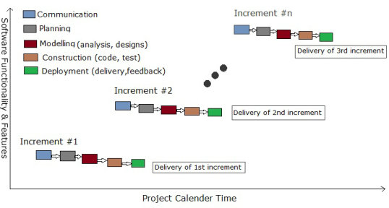

* ***Why Incremental Model?***
* Though there are many system development models are available, but incremental model is more suitable as per our project definition and other criteria (time, team members) of the project. Although other process models have their own advantages and disadvantages but they doesn’t suit because number of reasons. Like waterfall model’s biggest disadvantage is we can’t go one step back, V-model is not flexible if any changes occurs in requirements, in prototype model it is not possible to make so many prototype in order to involve stack holders in the development process because of close deadline, agile models are also acceptable when we have greater number of members development team as it contains tasks like pair programming etc.
* On the other hands we have number of following ***reasons*** for using incremental model –
* Core product is developed first i.e. main functionality is added in the first increment.
* Though numbers of members in development team are less, it can be easily implemented and work load is less.
* After each iteration, regression testing should be conducted. During this testing, faulty elements of the software can be quickly identified because few changes are made within any single iteration.
* It is generally easier to test and debug than other methods of software development because relatively smaller changes are made during each iteration. This allows for more targeted and rigorous testing of each element within the overall product.
* With each release a new feature is added to the product.
* Risk of changing requirement is reduced.

**CH-4 SYSTEM ANALYSIS AND DESIGN**

This chapter shows overall structure of the system. It contains use-case diagrams, activity diagrams, class diagram, system flow diagram, data dictionary, and user interface and system navigation.

* 1. **UML DIAGRAMS**

UML is a standardized modeling language enabling developers to specify, visualize, construct and document artifacts of a software system. It includes use case, activity, sequence and class diagram.

* **Use case Diagram**
* To model a system, the most important aspect is to capture the dynamic behaviour. Dynamic behaviour means the behaviour of the system when it is running / operating.
* Only static behavior is not sufficient to model a system rather dynamic behavior is more important than static behavior. In UML, there are five diagrams available to model the dynamic nature and use case diagram is one of them.
* Now as we have to discuss that the use case diagram is dynamic in nature, there should be some internal or external factors for making the interaction.
* These internal and external agents are known as actors. A use case diagram consists of actors, use cases and their relationships. The diagram is used to model the system/subsystem of an application. A single use case diagram captures a particular functionality of a system.
* Hence to model the entire system, a number of use case diagrams are used.
* In brief, the purposes of use case diagrams can be said to be as follows :
* Used to gather the requirements of a system.
* Used to get an outside view of a system.

Shows the interaction among the requirements is actors.

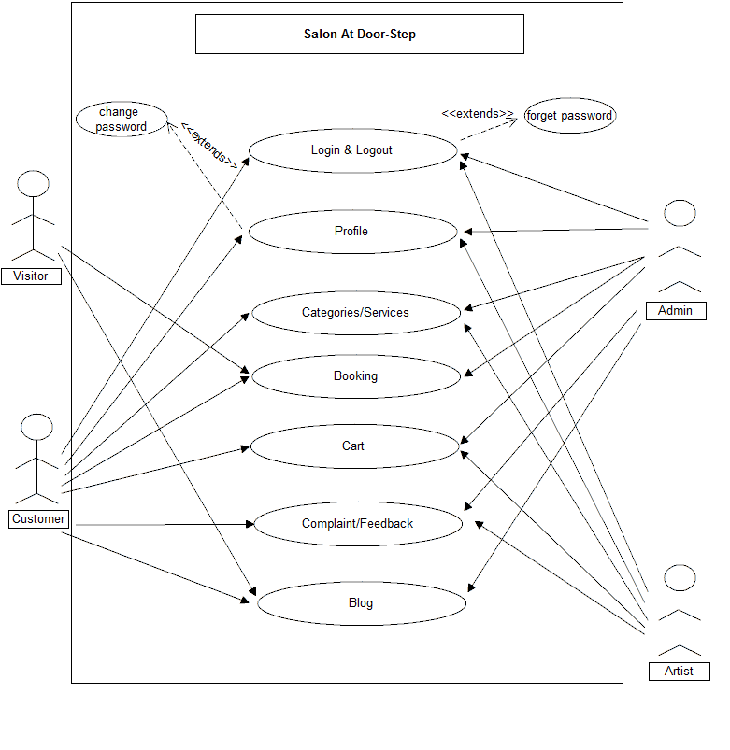

* **Activity Diagram**
* Activitydiagrams are graphical representations of workflows of stepwise activities and actions with support for choice, iteration and concurrency. In the Unified Modelling Language, activitydiagrams are intended to model both computational and organizational processes
* Activity diagram is another important diagram in UML to describe the dynamic aspects of the system.
* Activity diagram is basically a flowchart to represent the flow from one activity to another activity. The activity can be described as an operation of the system.
* The control flow is drawn from one operation to another. This flow can be sequential, branched, or concurrent. Activity diagrams deal with all type of flow control by using different elements such as fork, join, etc.
* The purpose of an activity diagram can be described as −
* Draw the activity flow of a system.
* Describe the sequence from one activity to another.
* Describe the parallel, branched and concurrent flow of the system.
* **Activity diagram – Admin**

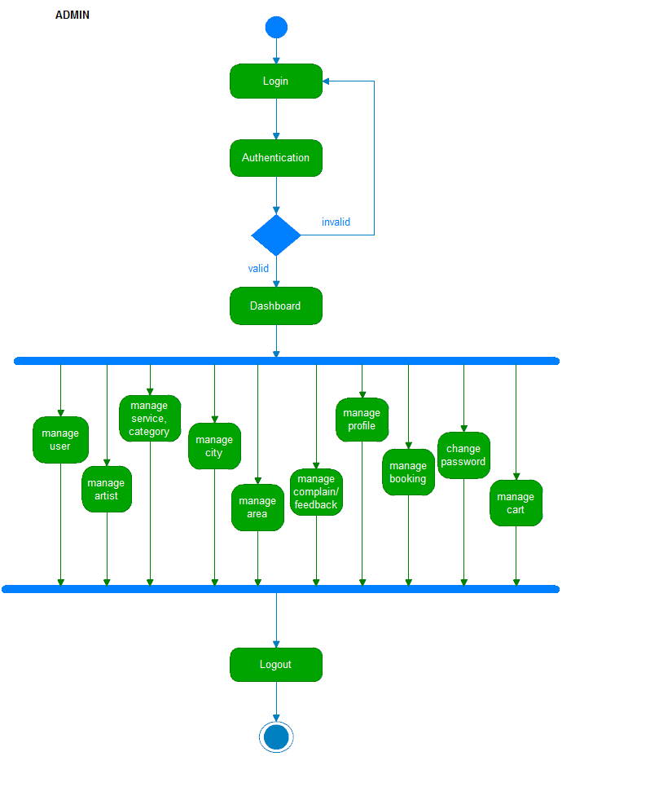

* **Activity diagram – Artist**

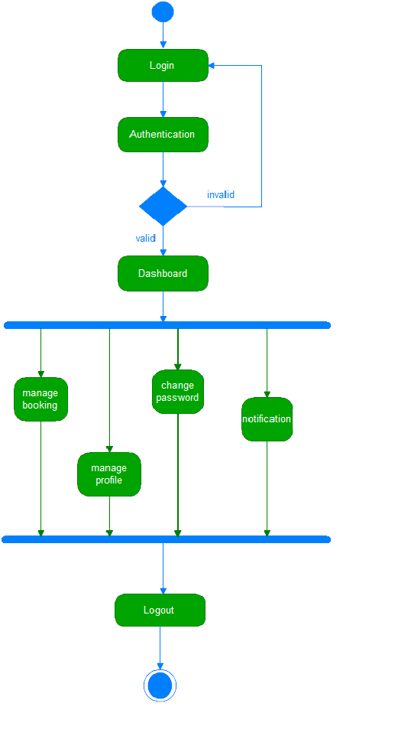

* **Activity Diagram – visitor**



* **Activity Diagram – user**

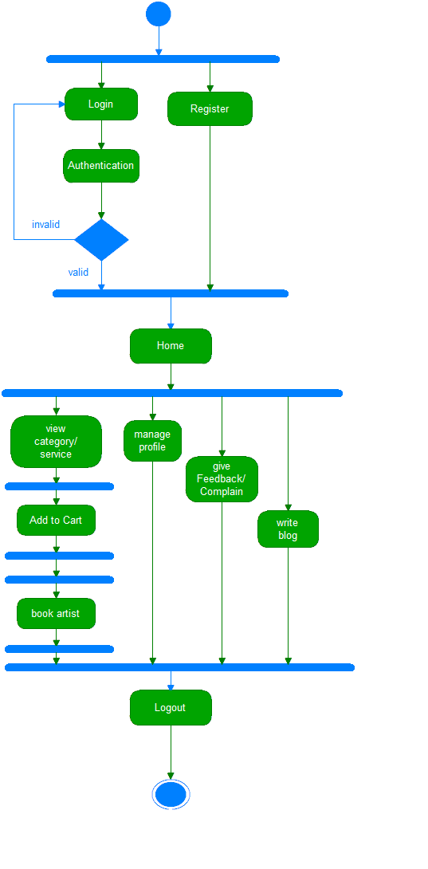

* **Class Diagram**
* Class diagram is a static diagram. It represents the static view of an application. Class diagram is not only used for visualizing, describing, and documenting different aspects of a system but also for constructing executable code of the software application.
* Class diagram describes the attributes and operations of a class and also the constraints imposed on the system. The class diagrams are widely used in the modeling of object oriented systems because they are the only UML diagrams, which can be mapped directly with object-oriented languages.
* Class diagram shows a collection of classes, interfaces, associations, collaborations, and constraints. It is also known as a structural diagram.
* The purpose of the class diagram can be summarized as −
* Analysis and design of the static view of an application.
* Describe responsibilities of a system.
* Base for component and deployment diagrams.
* Forward and reverse engineering.

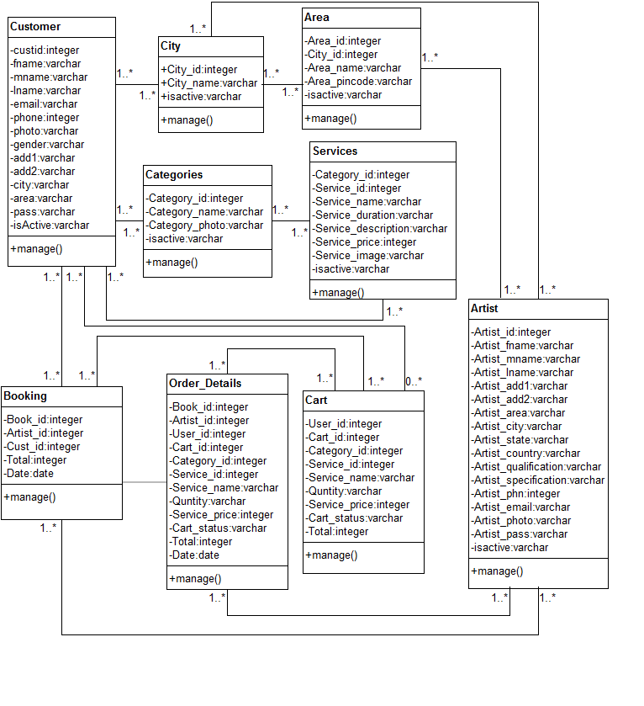

* **Sequence Diagram**

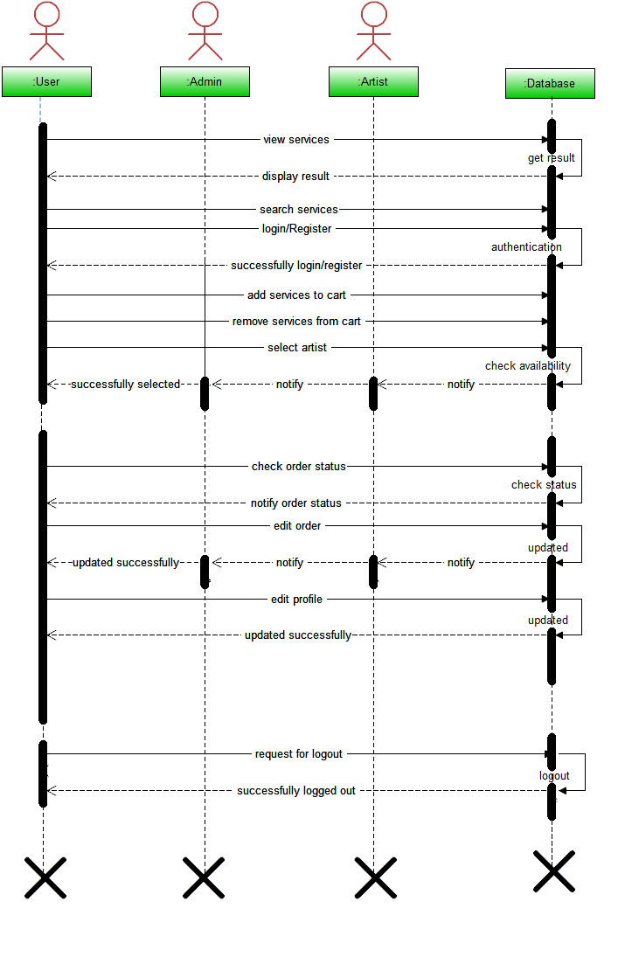

* 1. **SYSTEM FLOW DIAGRAM**

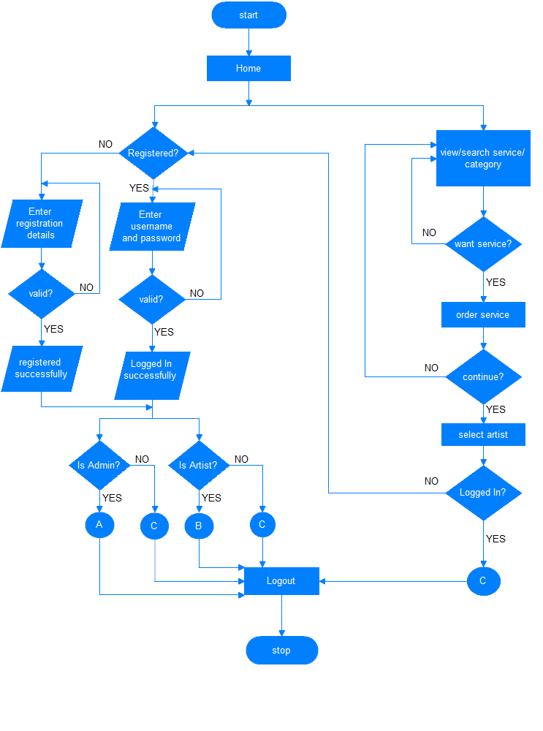

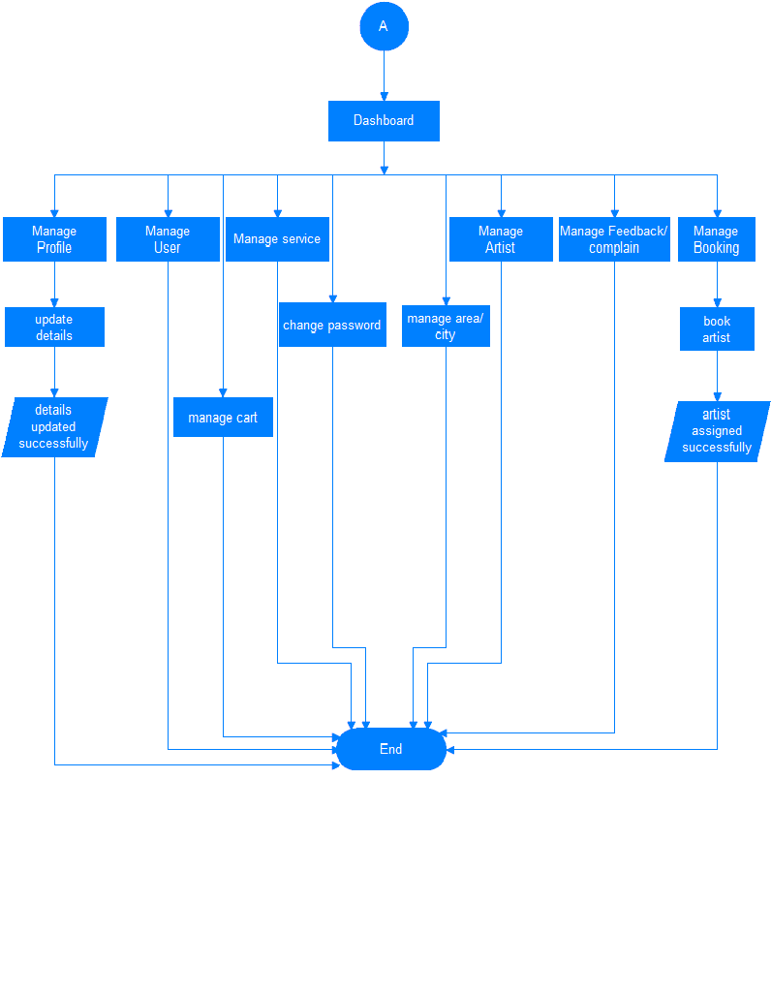

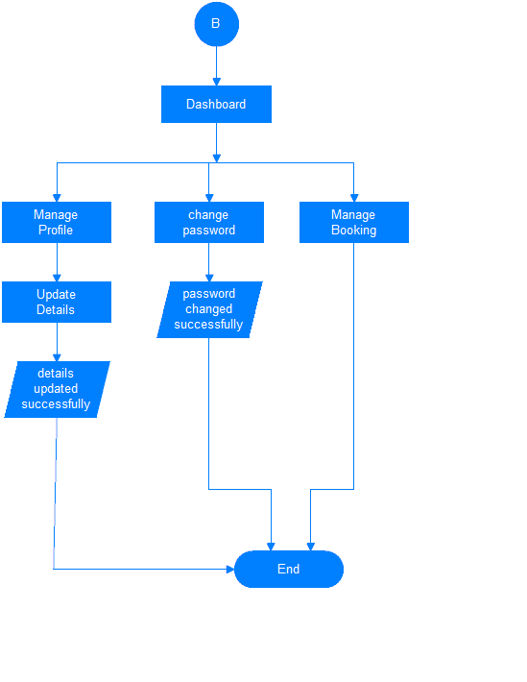

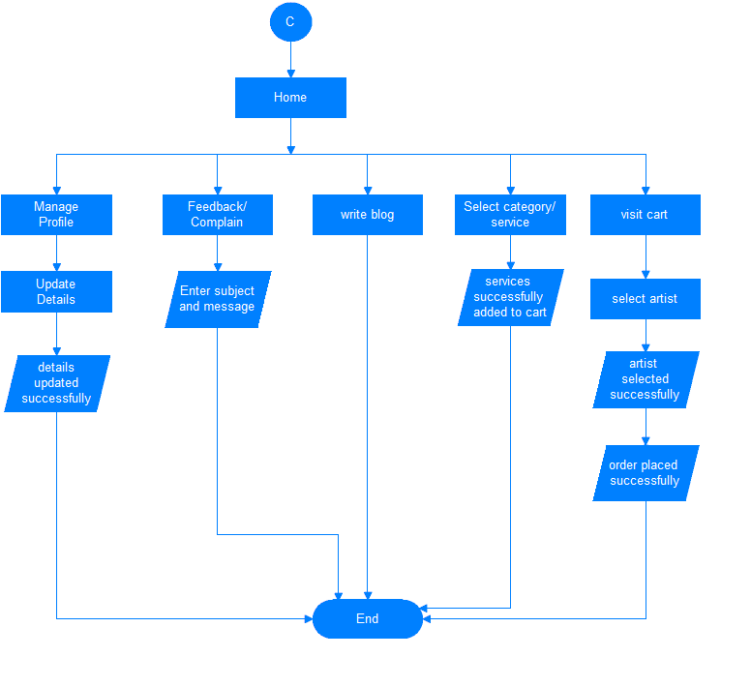

* 1. **DATA DICTIONARY**

**Customer table**

Table Name: Customer table

Primary key: Customer id

Description: This table shows the details about customer.

|  |  |  |  |  |
| --- | --- | --- | --- | --- |
| Fields | Data-type | Constrains | Remark | Description |
| Customer id | Integer(3) | Primary key | Auto increment | Customer’s id. |
| Customer fname | Varchar(30) | Not Null | - | Customer’s first name. |
| Customer mname | Varchar(30) | Not Null | - | Customer’s middle name. |
| Customer lname | Varchar(30) | Not Null | - | Customer’s last name |
| Customer email_id | Varchar(20) | Not Null | - | Customer’s mail id. |
| Customer photo | Varchar(50) | Not Null | - | Display Customer’s photo. |
| Mobile No. | Long integer(10) | Not Null | - | Customer’s mobile no. |
| Gender | Varchar(6) | Not Null | - | Display Customer’s gender. |
| Address1 | Varchar(50) | Not Null | - | Customer’s address1. |
| Address2 | Varchar(50) | Not Null | - | Customer’s address2. |
| City id | Integer(5) | Not Null | - | Customer’s city id. |
| Area id | Integer(3) | Not Null | - | Customer’s area id. |
| Password | Varchar(6) | Not Null | - | Customer’s password. |

**City table**

Table Name: City table

Primary key: City id

Description: This table shows the details about city.

|  |  |  |  |  |
| --- | --- | --- | --- | --- |
| Fields | Data-type | Constrains | Remark | Description |
| City id | Integer(3) | Primary key | Auto increment | Display city id. |
| City name | Varchar(20) | Not Null | - | Display city name. |

**Area table**

Table Name: Area table

Primary key: Area id

Description: This table shows the details about area.

|  |  |  |  |  |
| --- | --- | --- | --- | --- |
| Fields | Data-type | Constrains | Remark | Description |
| Area id | Integer(3) | Primary key | Auto increment | Display area id. |
| City id | Integer(3) | Foreign key | - | Display city id. |
| Area name | Varchar(50) | Not Null | - | Area name. |
| Area pincode | Varchar(6) | Not Null | - | Area pincode. |

**Category table**

Table Name: Category table

Primary key: Cat id

Description: This table shows the details about category.

|  |  |  |  |  |
| --- | --- | --- | --- | --- |
| Fields | Data-type | Constrains | Remark | Description |
| Cat id | Integer(3) | Primary key | Auto increment | Category id. |
| Cat name | Varchar(30) | Not Null | - | Category name. |
| Cat Image | Varchar(100) | Not Null | - | Display image. |

**Blog table**

Table Name: Category table

Primary key: Cat id

Description: This table shows the details about category.

|  |  |  |  |  |
| --- | --- | --- | --- | --- |
| Fields | Data-type | Constrains | Remark | Description |
| Blog_id | Integer(3) | Primary key | Auto increment | Blog id. |
| User_id | Varchar(3) | Foreign Key | - | Id of user who write the blog name. |
| User_Image | Varchar(100) | Not Null | - | Display user’s image. |
| User_name | Varchar(50) | Not Null | - | Display user’s name |
| User_email | Varchar(20) | Not Null | - | Display user’s email. |
| Comment | Varchar(500) | Not Null | - | Display user’s comment |

**Service table**

Table Name: Service table

Primary key: Service id

Description: This table shows the details about service.

|  |  |  |  |  |
| --- | --- | --- | --- | --- |
| Fields | Data-type | Constrains | Remark | Description |
| Service id | Integer(3) | Primary key | Auto increment | Service id. |
| Cat id | Integer(3) | Foreign key | - | Category id. |
| Service name | Varchar(30) | Not Null | - | Service name. |
| Service duration | Varchar(10) | Not Null | - | Service duration. |
| Service description | Varchar(500) | Not Null | - | Service description. |
| Service photo | Varchar(50) | Not Null | - | Service photo. |
| Service price | Integer(5) | Not Null | - | Service price. |

**Contact table**

Table Name: Contact table

Primary key: contact_id

Description: This table shows the details about feedback or complains of customer.

|  |  |  |  |  |  |  |
| --- | --- | --- | --- | --- | --- | --- |
| Fields | Data-type | Constrains | Remark | | | Description |
| Contact_id | Integer(3) | Primary key | Auto increment | | | Feedback/  complain id. |
| User_id | Integer(5) | Foreign key | - | | | Id of user who write feedback or complain |
| User_name | Integre(30) | Foreign key | - | Name of user who write feedback or complain | | |
| User_email | Varchar(20) | NOT NULL | - | | Email address of particular user | |
| Contact_type | Varchar(10) | NOT NULL | - | | Feedback/Complain | |
| Contact_subject | Varchar(50) | - | - | | Subject of feedback or complain | |
| Contact_messageg | Varchar(500) | NOT NULL | - | | Feedback or complain of customer | |

**Booking_Details table**

Table Name: Booking_details table

Primary key: booking_id

Description: This table shows the details about details of booking order .

|  |  |  |  |  |
| --- | --- | --- | --- | --- |
| Fields | Data-type | Constrains | Remark | Description |
| Booking_id | Integer(3) | Primary Key | Auto Increment | Id of booking details. |
| User_id | Integer (3) | Foreign Key | - | Display user id. |
| Order_id | Integer (3) | Foreign Key | - | Display order id. |
| Cart_id | Integer (3) | Foreign Key | - | Display cart id. |
| Category_id | Integer(3) | Foreign Key | - | Display category id. |
| Service_id | Integer (3) | Foreign Key | - | Display service id. |
| Service_name | Varchar(50) | Not Null | - | Display service name. |
| Service_duration | Varchar(10) | Not Null | - | Display Service duration. |
| Quantity | Varchar(1) | Not Null | - | Display service quantity. |
| Service price | Integer(5) | Not Null | - | Display Service price. |
| Date | Varchar(10) | Not Null | - | Display booking date. |
| Time | Varchar(10) | Not Null | - | Display booking time. |
| Artist_id | Integer(3) | Not Null | - | Display Artist id. |
| Artist_name | Varchar(50) | Not null | - | Display artist name. |
| Order_status | Varchar(50) | Not Null | - | Display order status. |

**Cart table**

Table Name: Cart table

Primary key: cart id

Description: This table shows the details about cart.

|  |  |  |  |  |
| --- | --- | --- | --- | --- |
| Fields | Data-type | Constrains | Remark | Description |
| Cart id | Integer(3) | Primary key | Auto increment. | Shows cart id. |
| User id | Integer(3) | Foreign key | - | Display user id. |
| Service id | Integer(3) | Foreign key | - | Display service id. |
| Cat id | Integer(3) | Foreign key | - | Display category id. |
| Service name | Varchar(50) | Not Null | - | Display service name. |
| Service Duration | Varchar(10) | Not Null | - | Display service duration. |
| Price | Integer(5) | Not Null | - | Display service price. |
| Quantity | Integer(1) | Not Null | - | Show Quantity. |
| Cart status | Integer(10) | Not Null | - | Show cart status. |
| Total Price | Integer(10) | Not Null | - | Display total services. |
| Total Duration | Varchar(10) | Not Null | - | Display total duration. |

**Order table**

Table Name: Order table

Primary key:Order_id

Description: This table shows the details about Order.

|  |  |  |  |  |
| --- | --- | --- | --- | --- |
| Fields | Data-type | Constrains | Remark | Description |
| Order id | Integer(3) | Primary key | Auto increment | Display order id. |
| User id | Integer(3) | Foreign Key | - | Customer id. |
| Grand Total | Integer(5) | Not Null | - | Display total of selected services. |
| Date | Varchar(10) | Not Null | - | Display booking date. |
| Time | Varchar(10) | Not Null | - | Display Booking time. |
| Artist id | Integer(3) | Foreign Key | - | Display Artist id. |
| Artist Name | Varchar(50) | Not Null | - | Display name of selected artist. |
| Order Status | Varchar(20) | Not Null | - | Disaply order status. |
| Total Duration | Varchar(10) | Not Null | - | Display total service duration. |

|  |  |  |  |  |
| --- | --- | --- | --- | --- |
| Fields | Data-type | Constrains | Remark | Description |
| Artist id | Integer(3) | Primary key | Auto increment | Artist’s id. |
| Artist fname | Varchar(40) | Not Null | - | Artist’s first name. |
| Artist mname | Varchar(40) | Not Null | - | Artist’s middle name. |
| Artist lname | Varchar(40) | Not Null | - | Artist’s last name |
| Artist email_id | Varchar(20) | Not Null | - | Artist’s mail id. |
| Artist photo | Varchar(50) | Not Null | - | Display Artist’s photo. |
| Mobile No. | Long integer(10) | Not Null | - | Artist’s mobile no. |
| Gender | Varchar(6) | Not Null | - | Display Artist’s gender. |
| Address1 | Varchar(50) | Not Null | - | Artist’s address1. |
| Address2 | Varchar(50) | Not Null | - | Artist’s address2. |
| City id | Integer(3) | Not Null | - | Artist’s city id. |
| Area id | Integer(3) | Not Null | - | Artist’s area id. |
| State | Varchar(8) | Not Null | - | Artist’s state. |
| Country | Varchar(5) | Not Null | - | Artist’s country. |
| Qualification | Varchar(100) | Not Null | - | Display qualification. |
| Specification | Varchar(100) | Not Null | - | Display specification. |
| Password | Varchar(6) | Not Null | - | Artist’s password. |

**Artist table**

Tabl Name: Artist table

Primary key: Artist id

Description: This table shows the details about artist.

* 1. **USER INTERFACE**

**Visitor –Index:-**

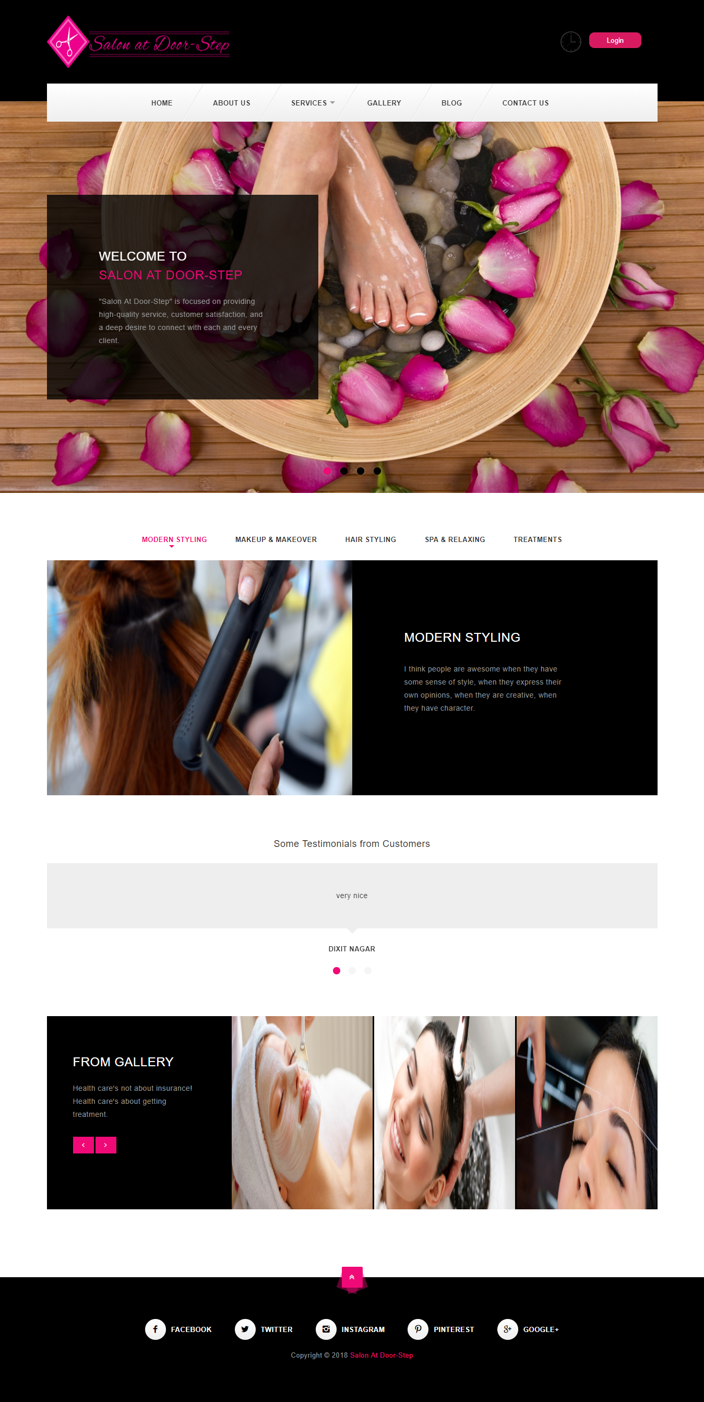

**Visitor-Blog:-**

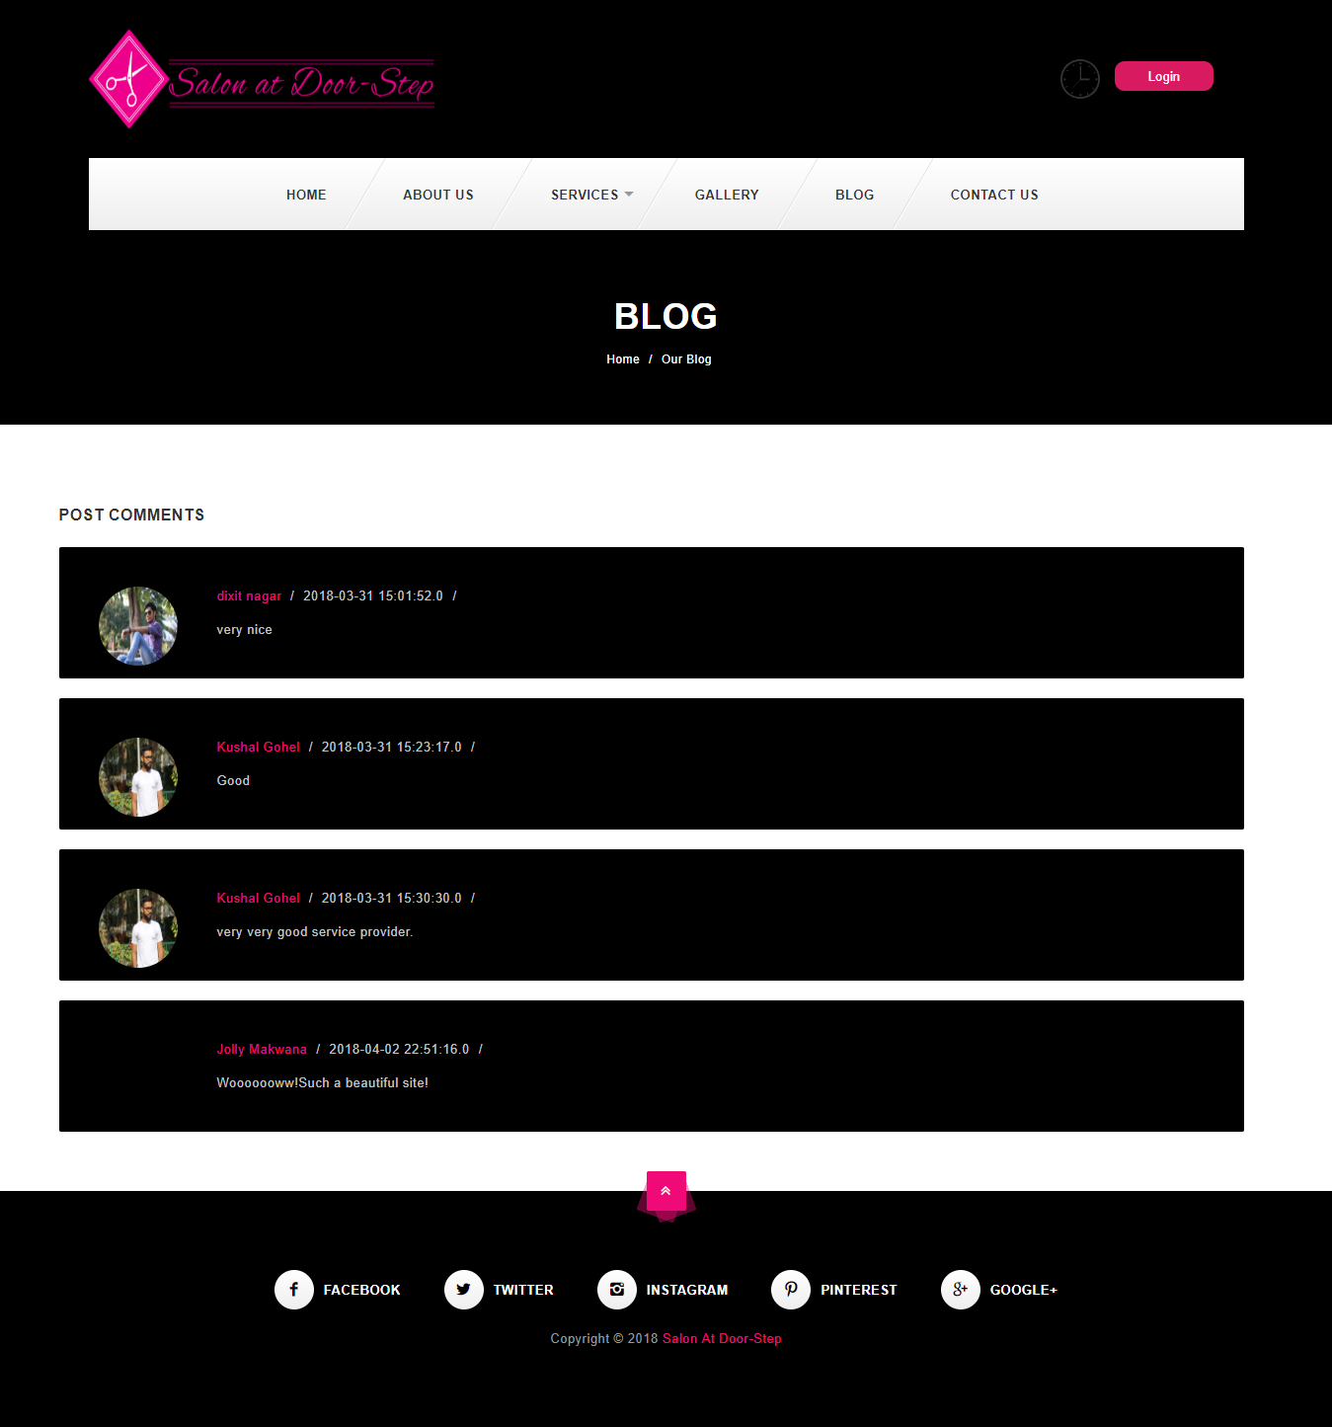

**Login:-**

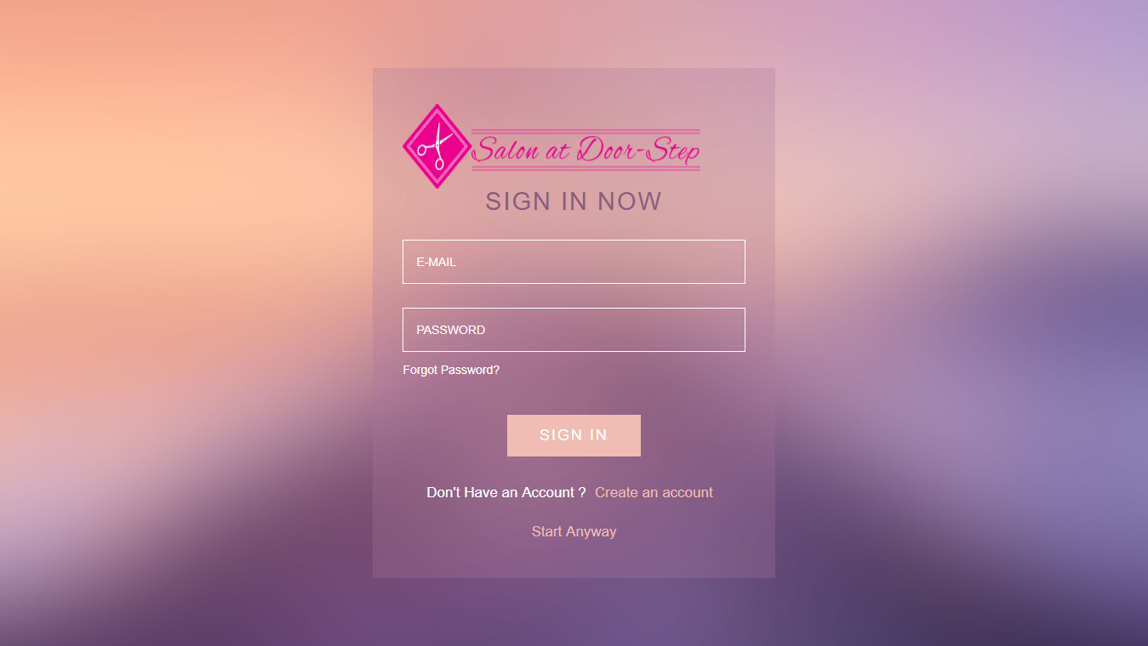

**Registration:-**

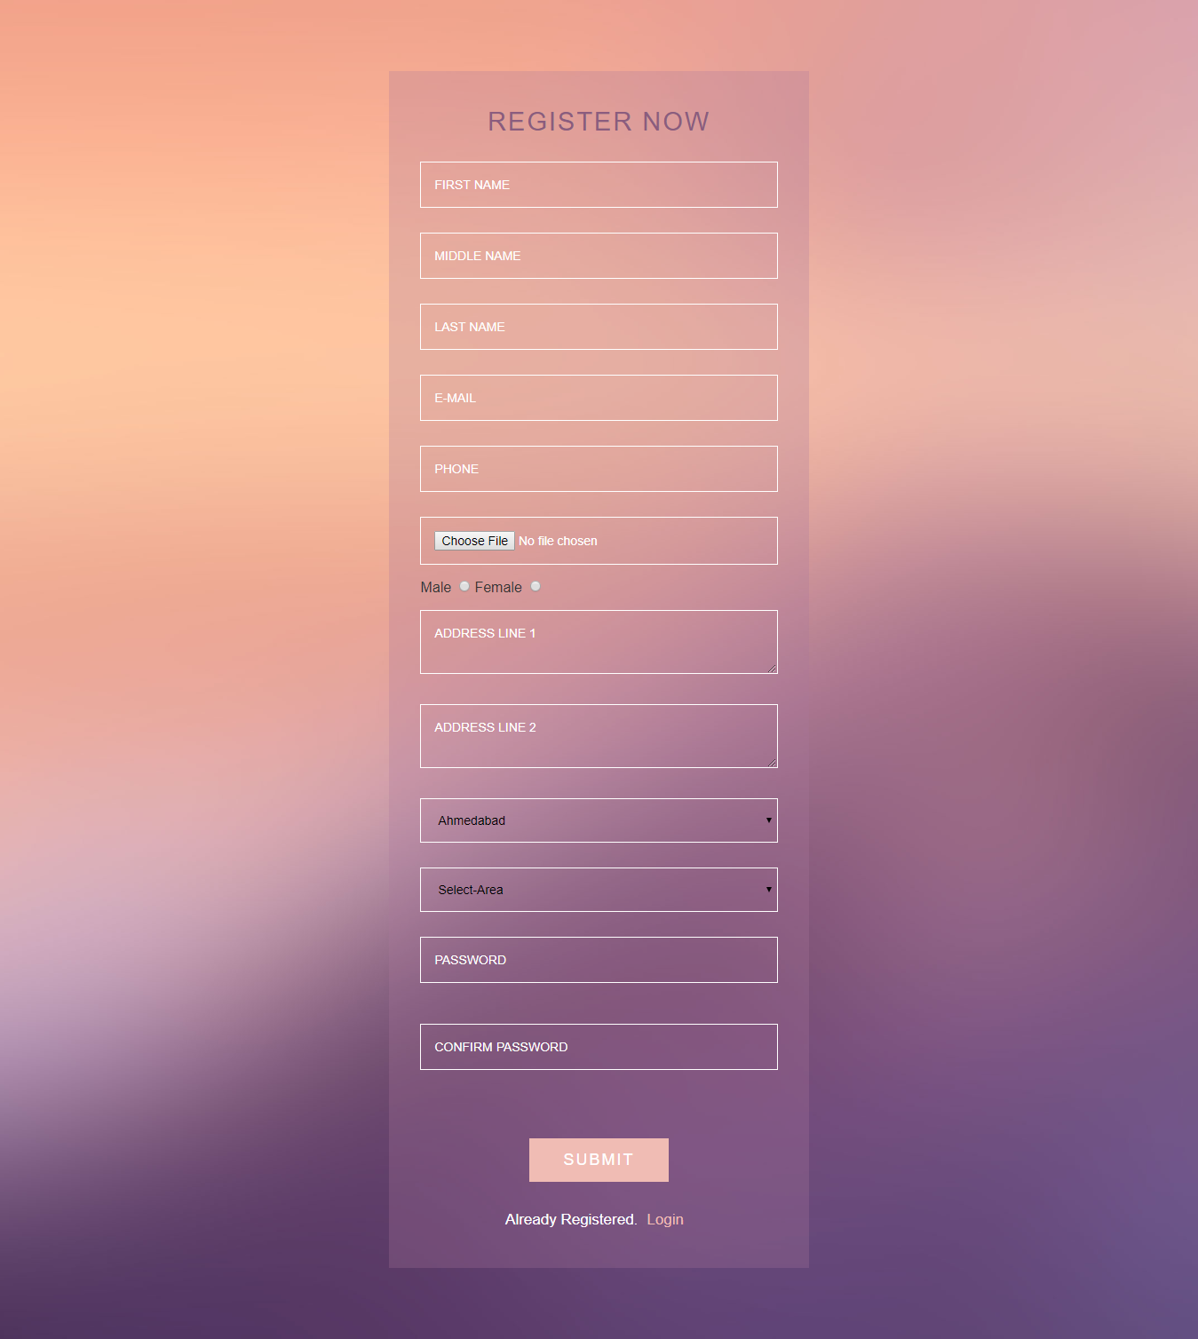

**Forget Password:-**

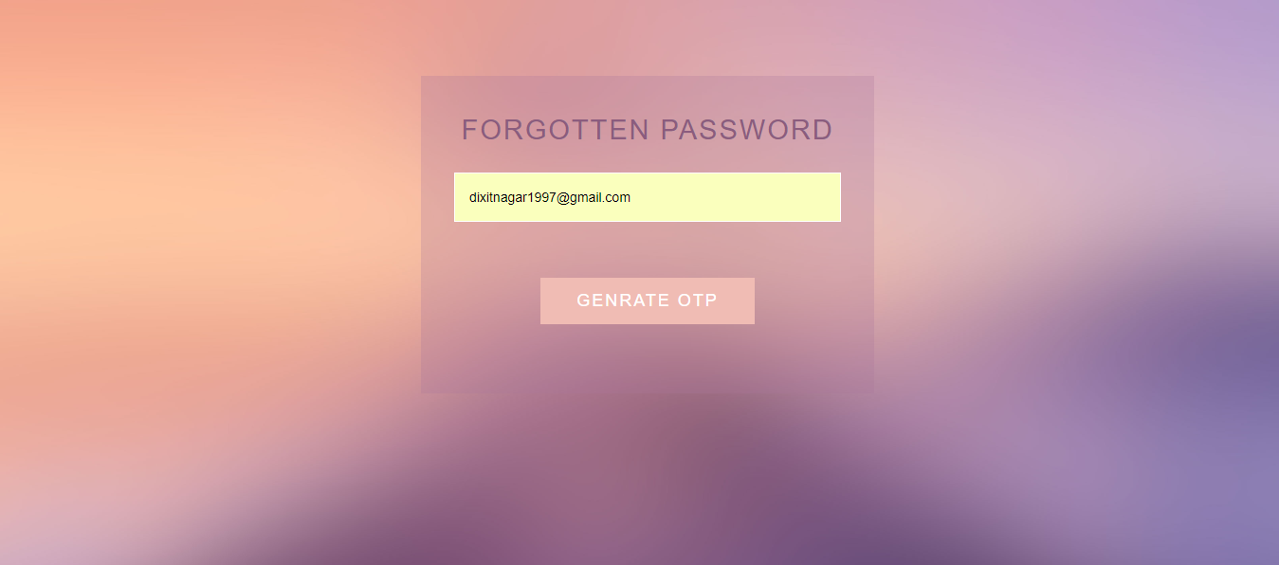

**Index:-**

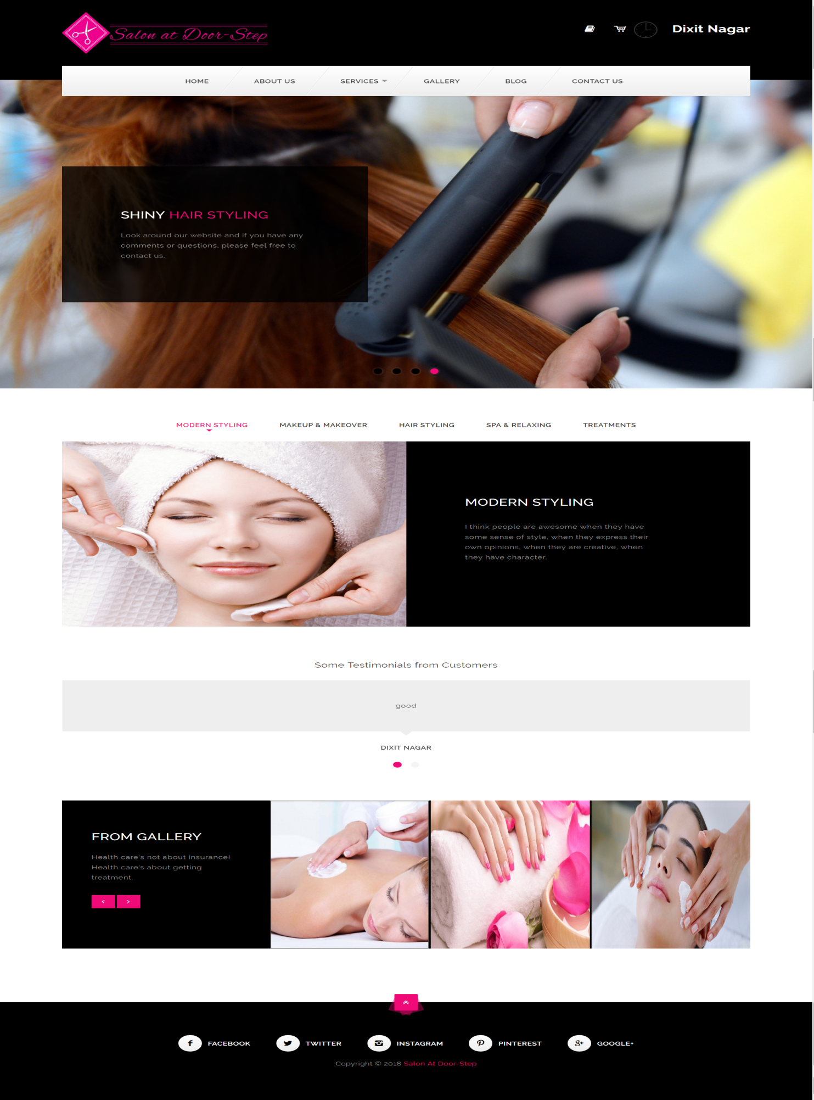

**About Us :-**

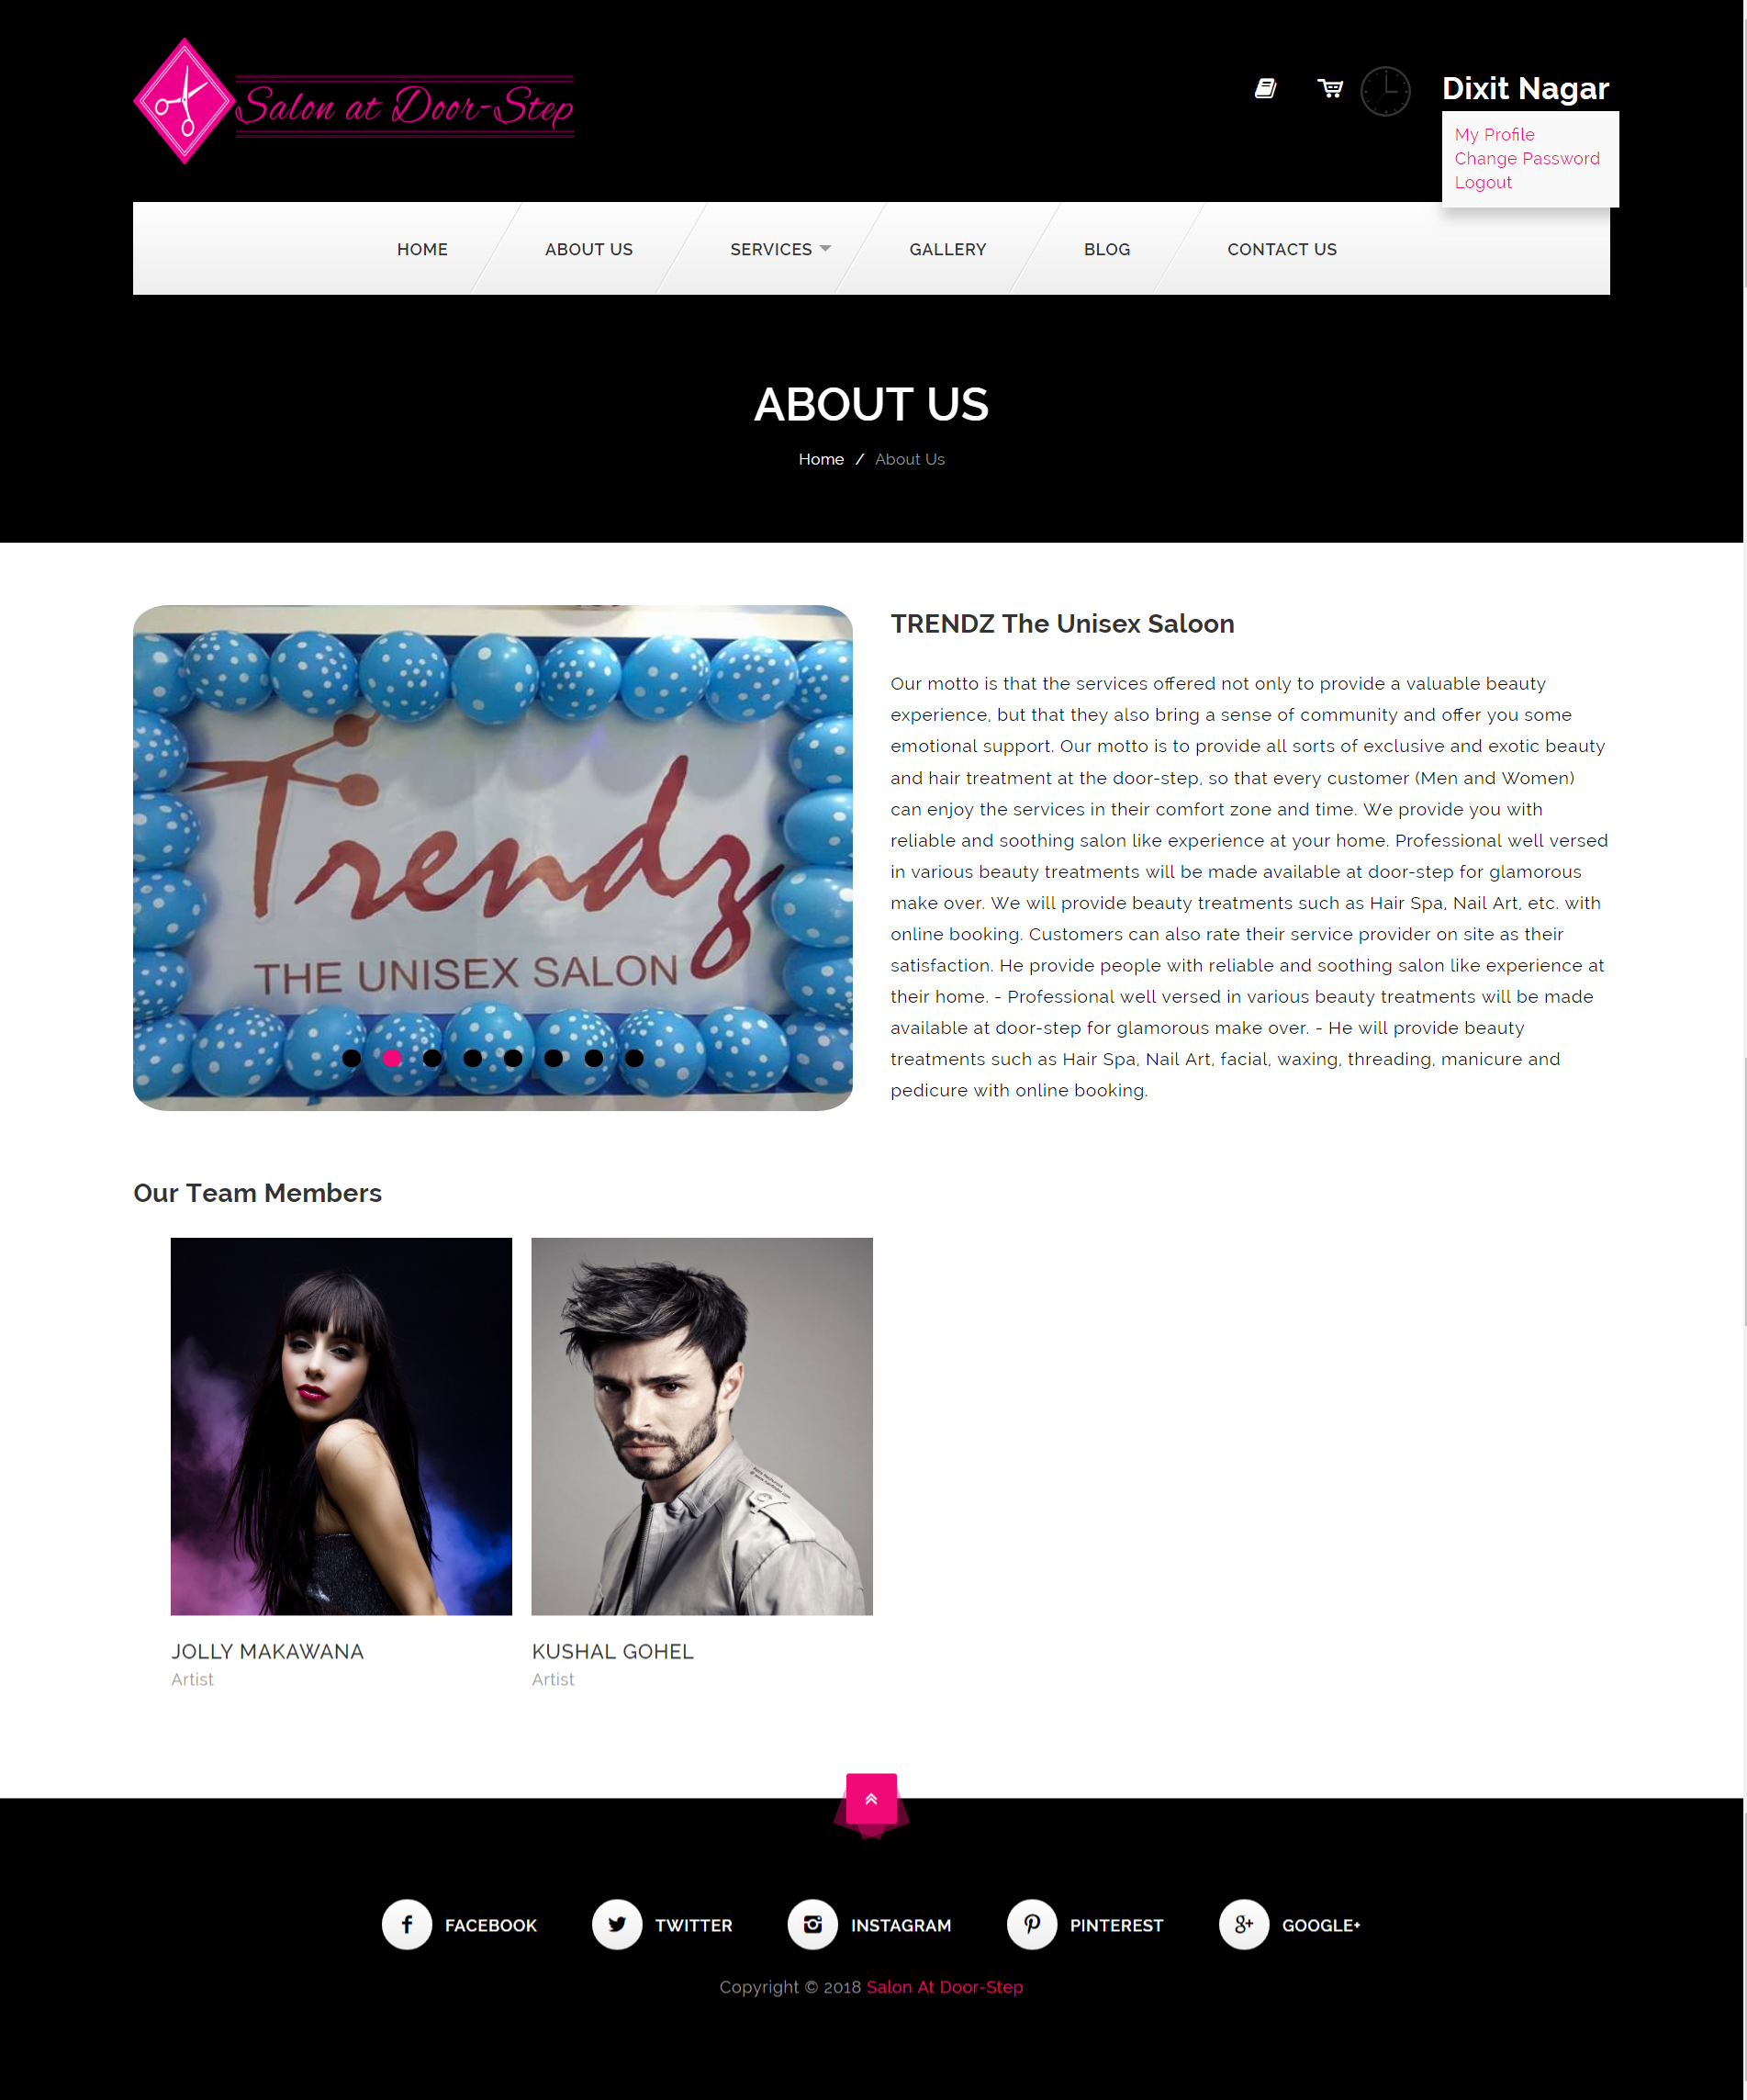

**Services:-**

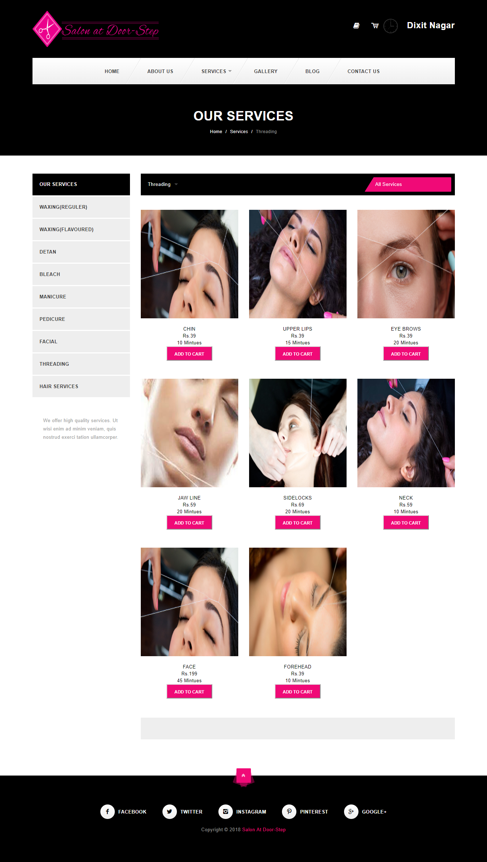

**Service Description:-**

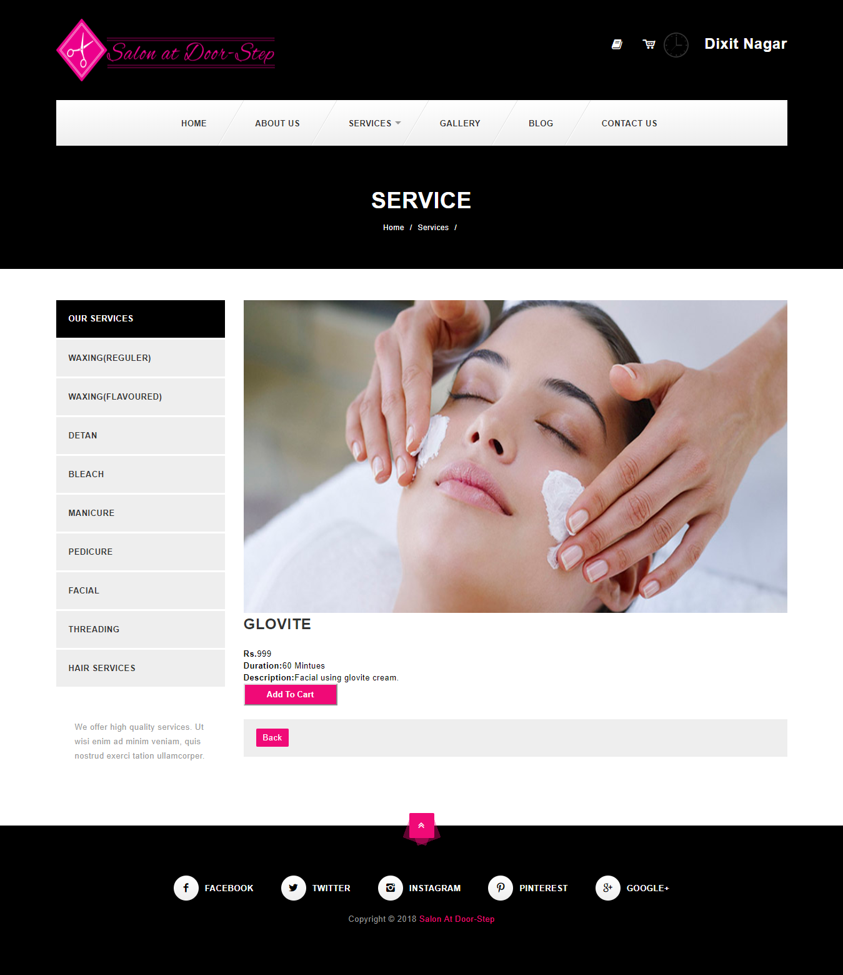

**Gallery :-**

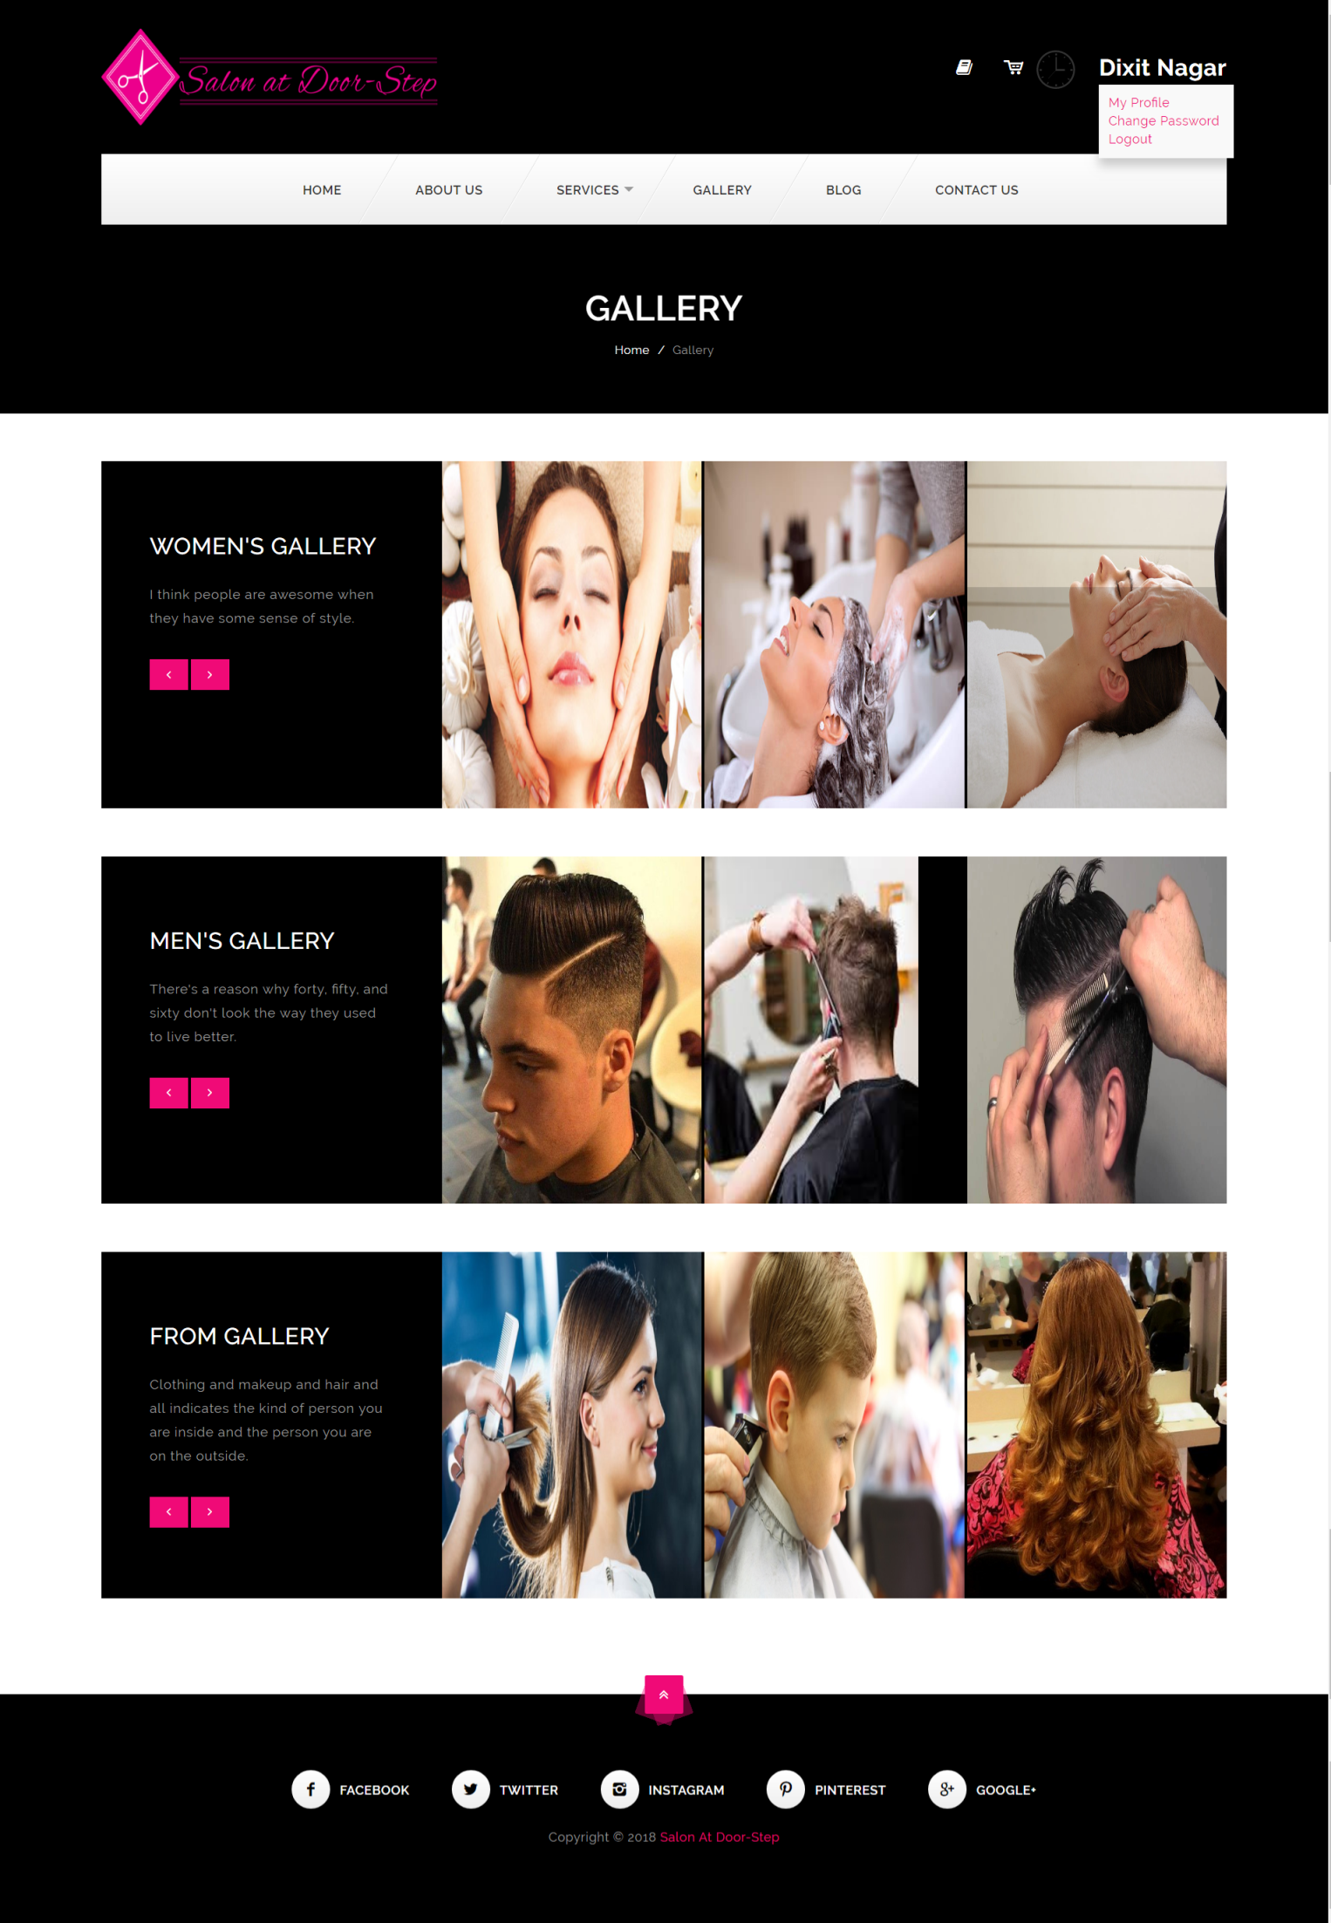

**Blog :-**

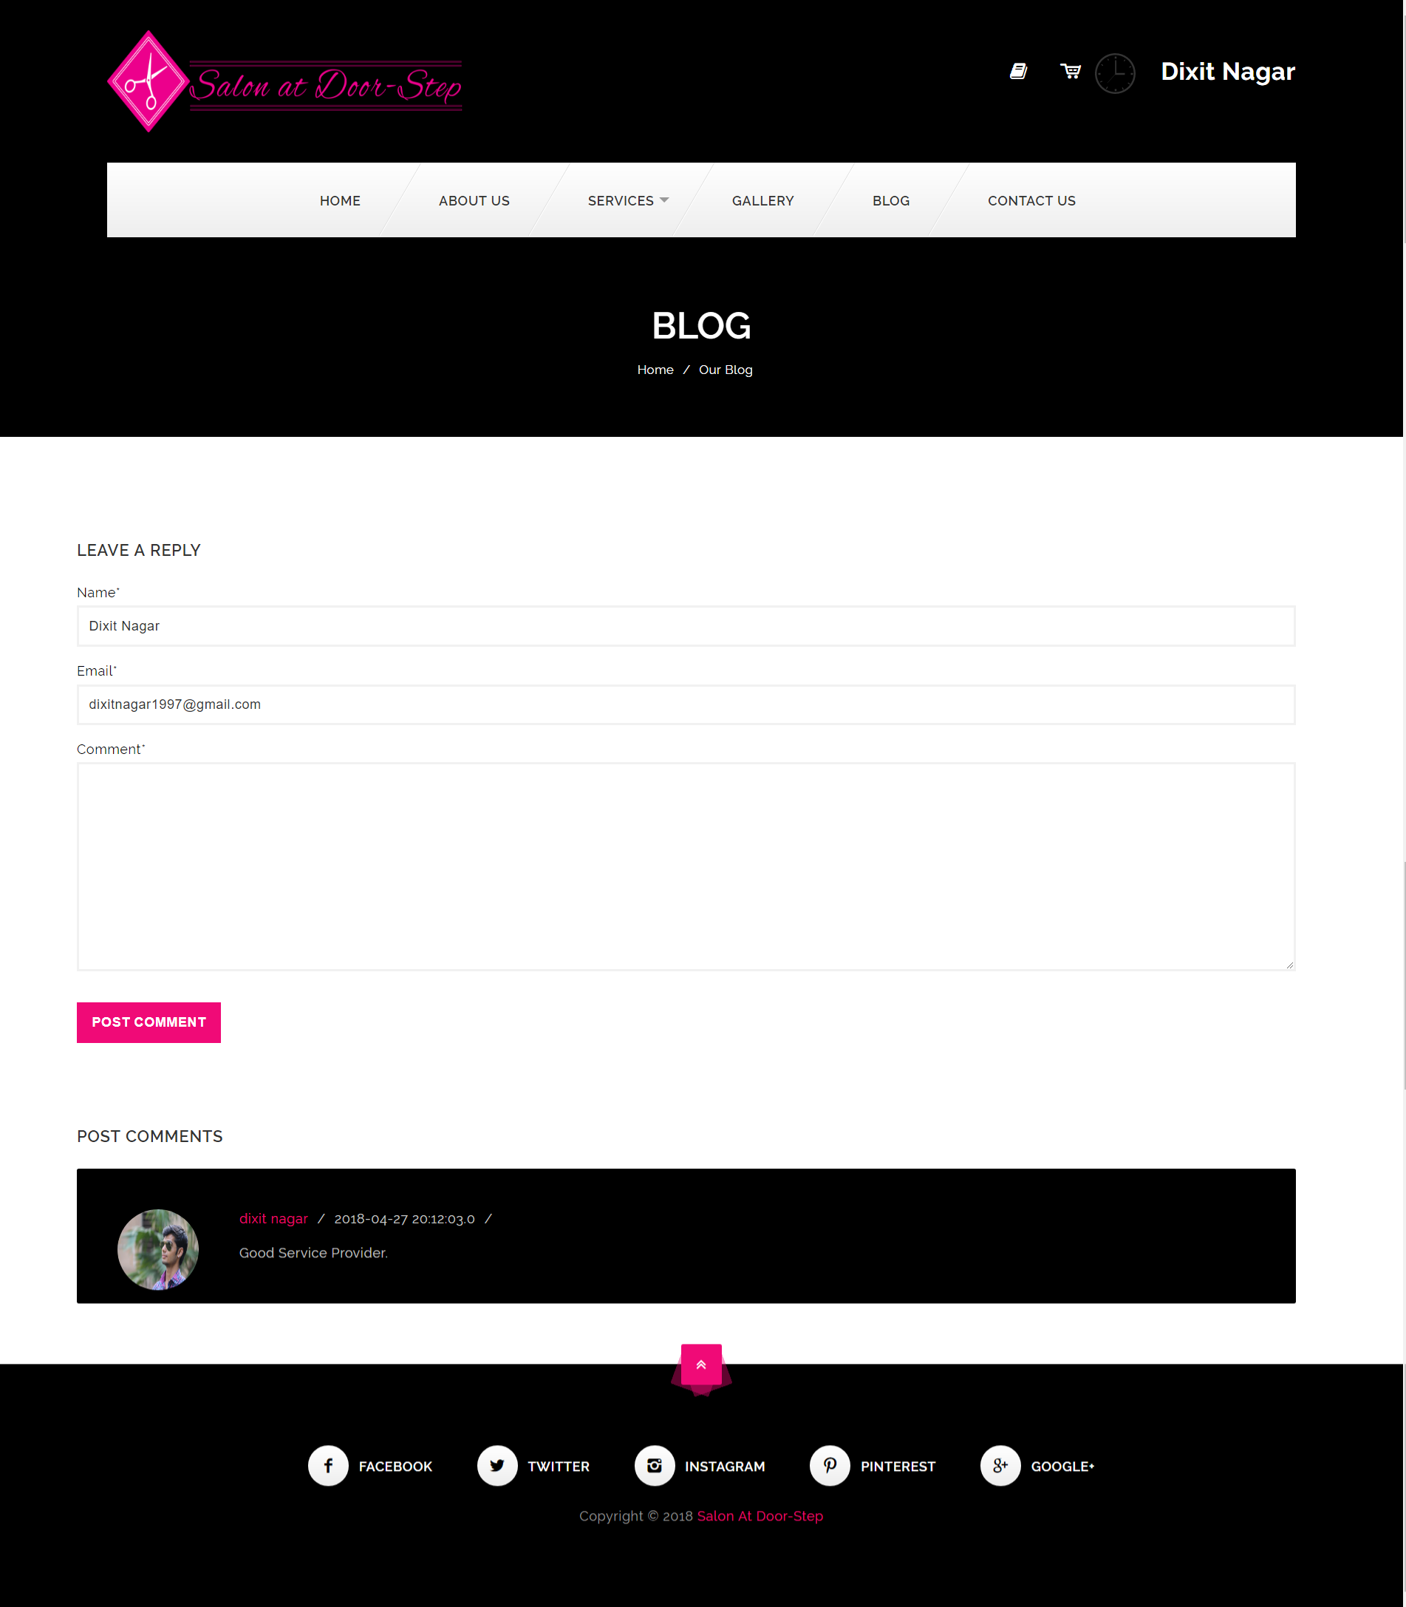

**Contact Us :-**

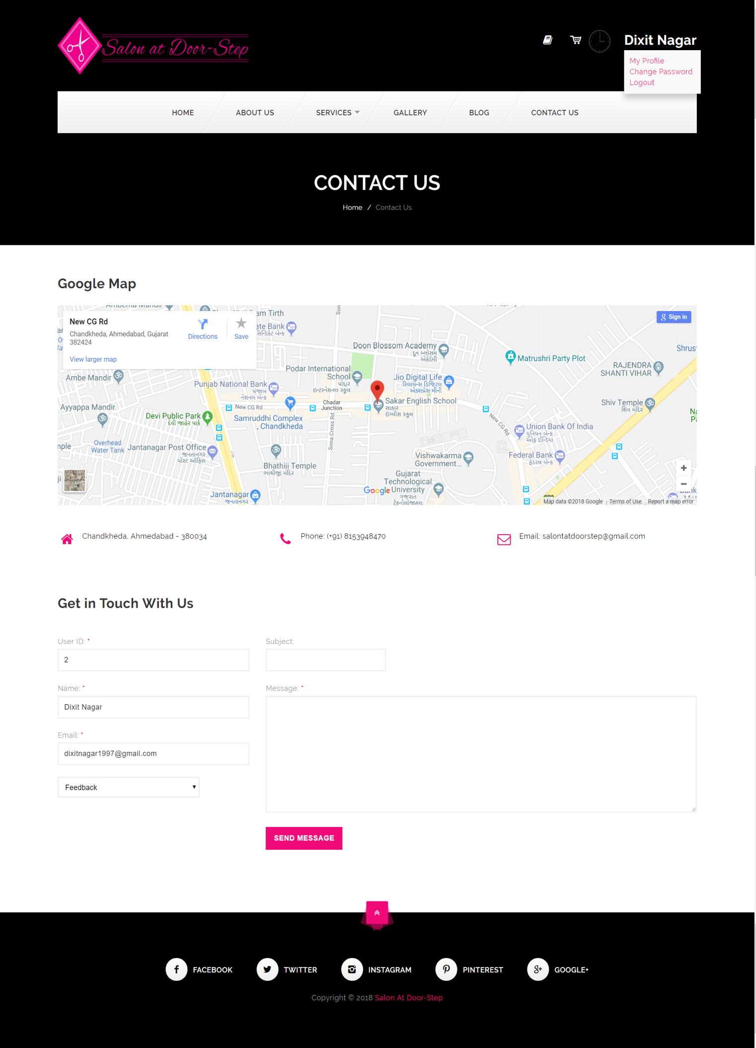

**Cart :-**

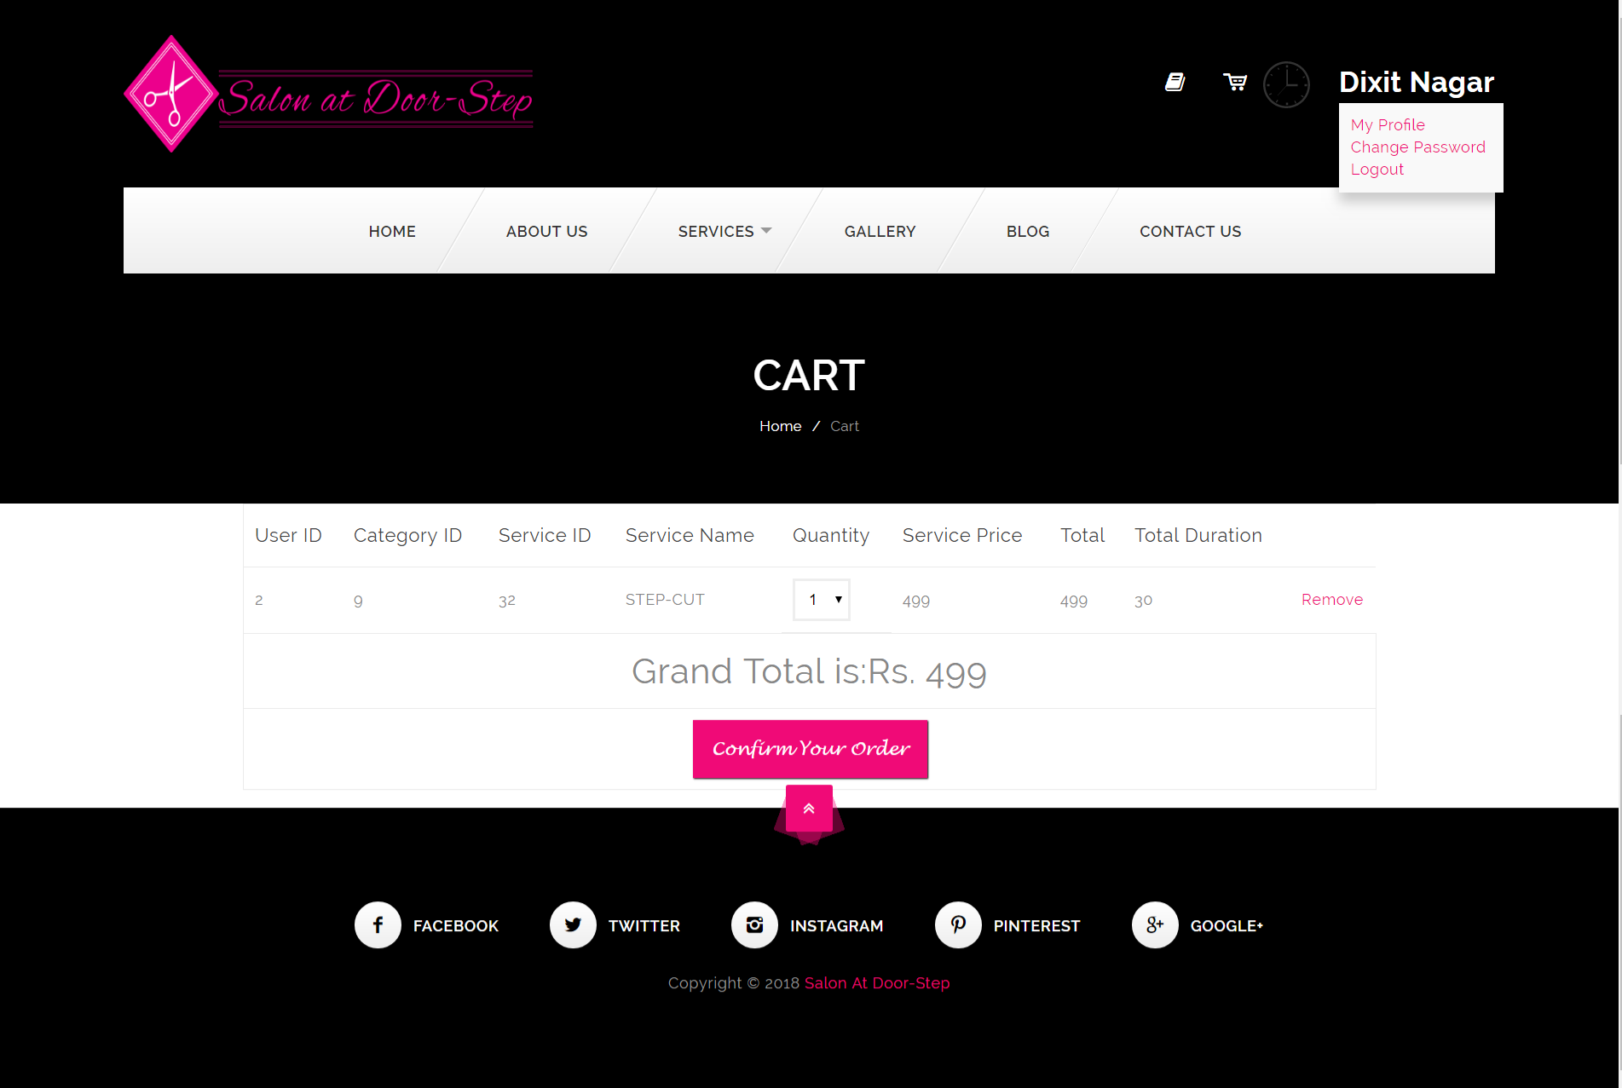

**Booking Details:-**

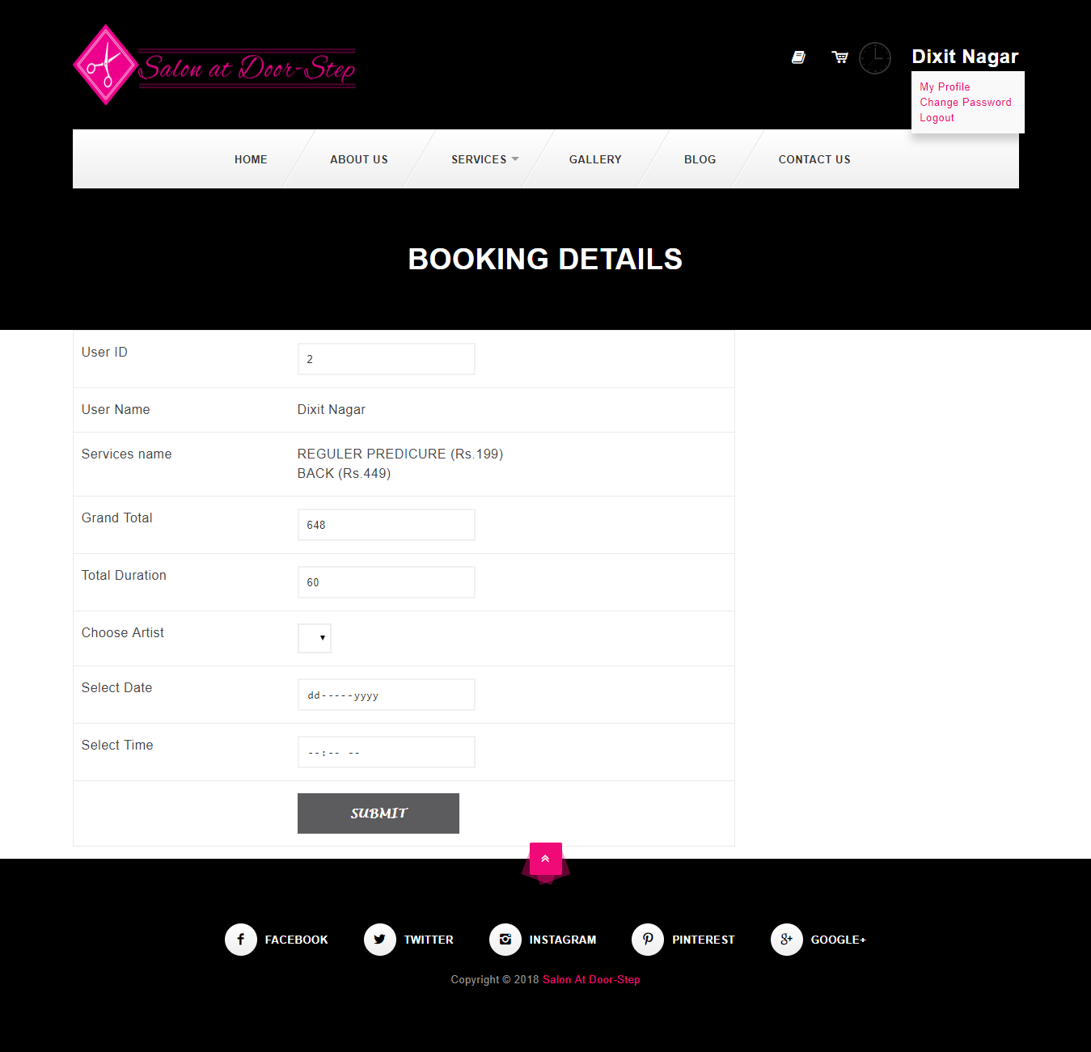

**Order:-**

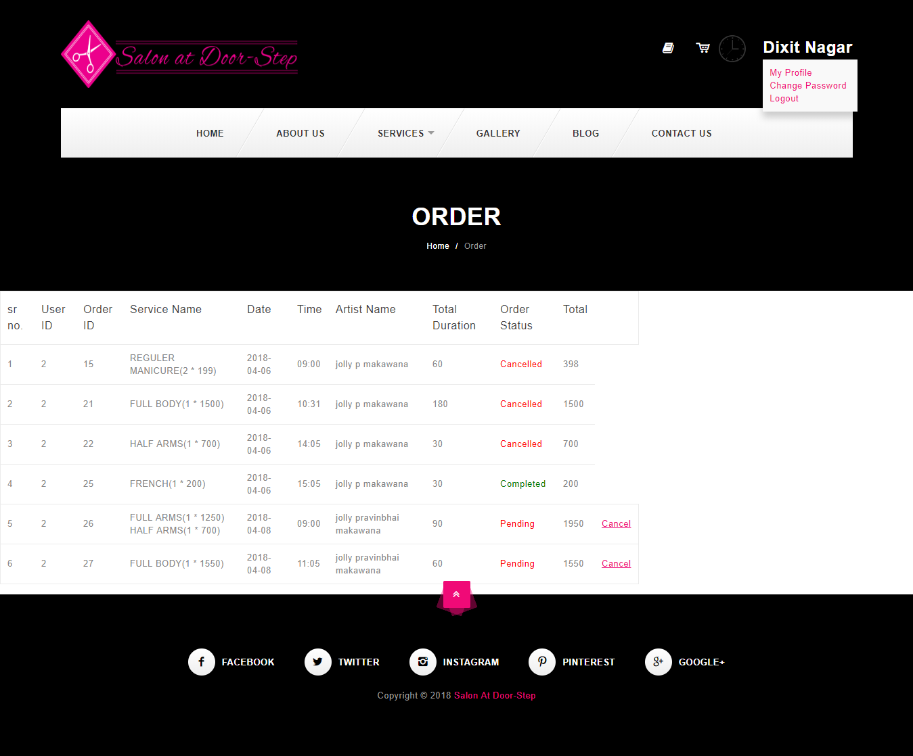

**Opening Time:-**

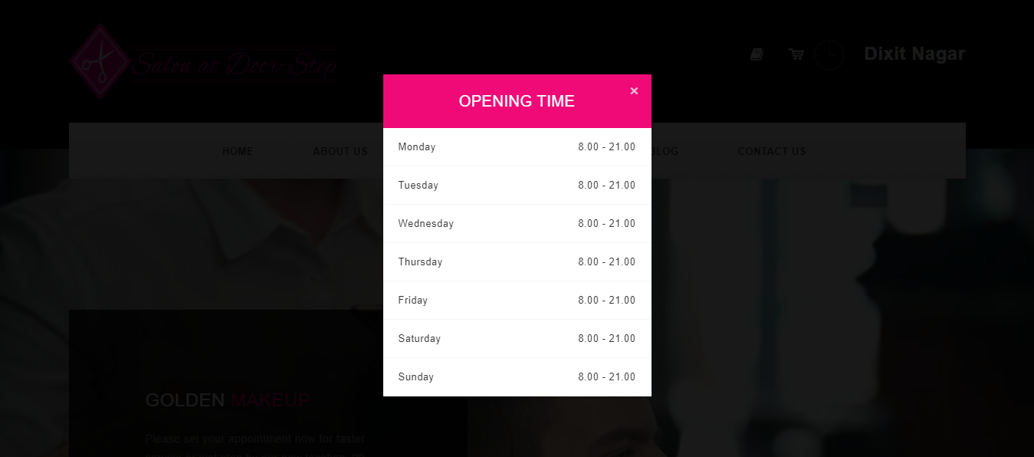

**Profile:-**

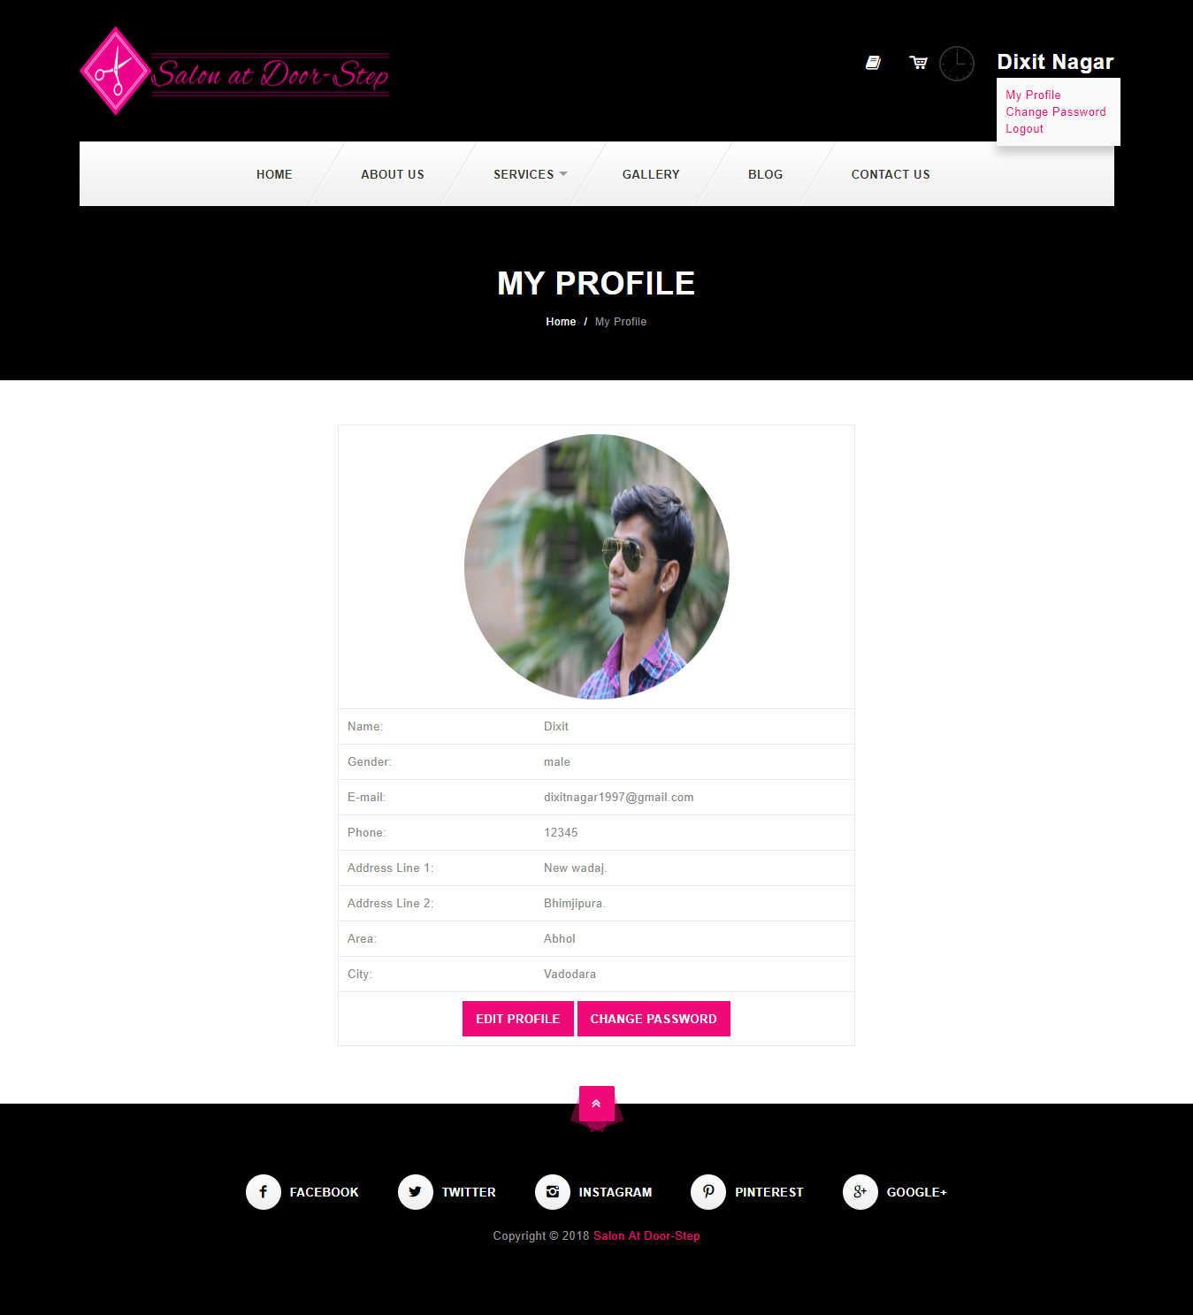

**Change Password:-**

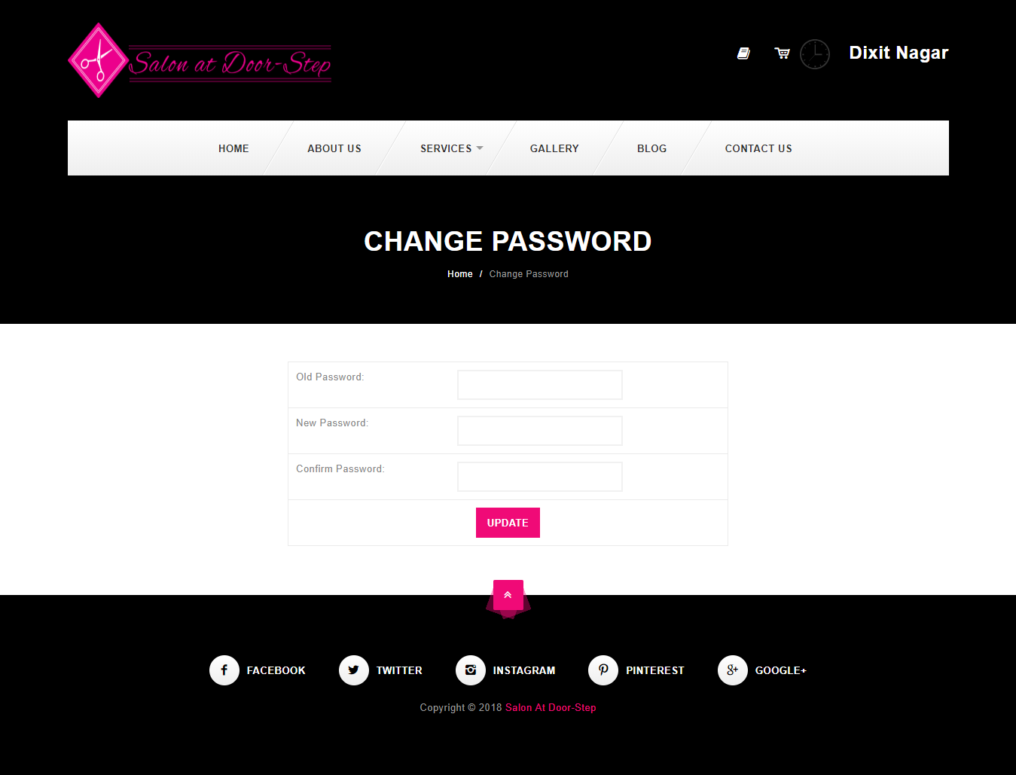

* 1. **SYSTEM NAVIGATION**

**Admin**

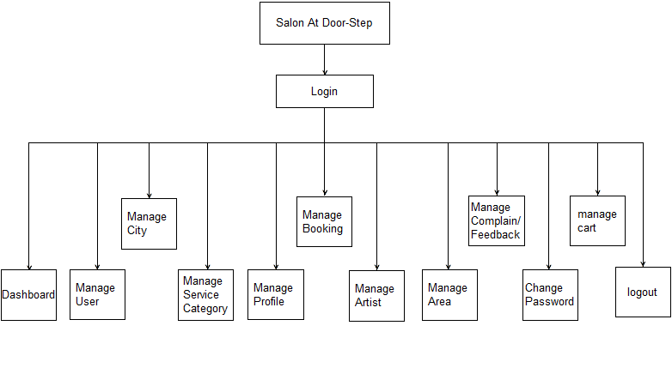

**Artist**

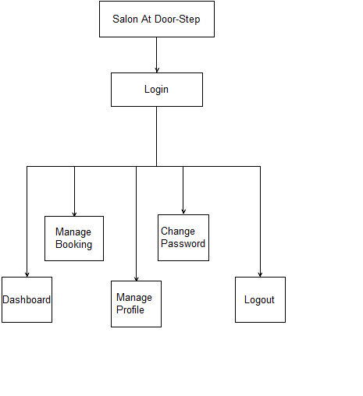

**User**

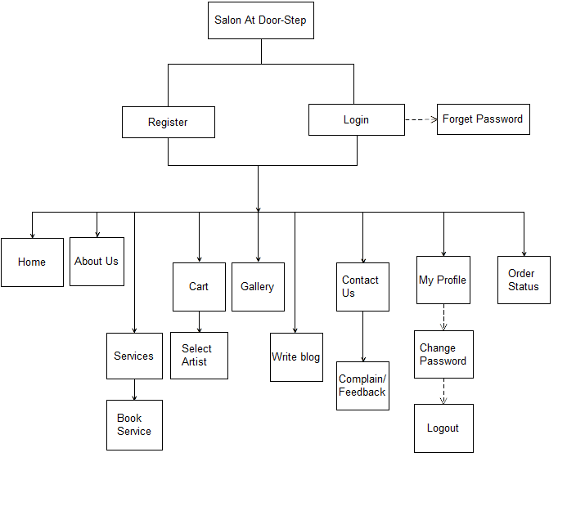

**CH-5 INPUT / OUTPUT DESIGN**

This chapter shows data insertion and output generated by it.

**Input-Add Area**

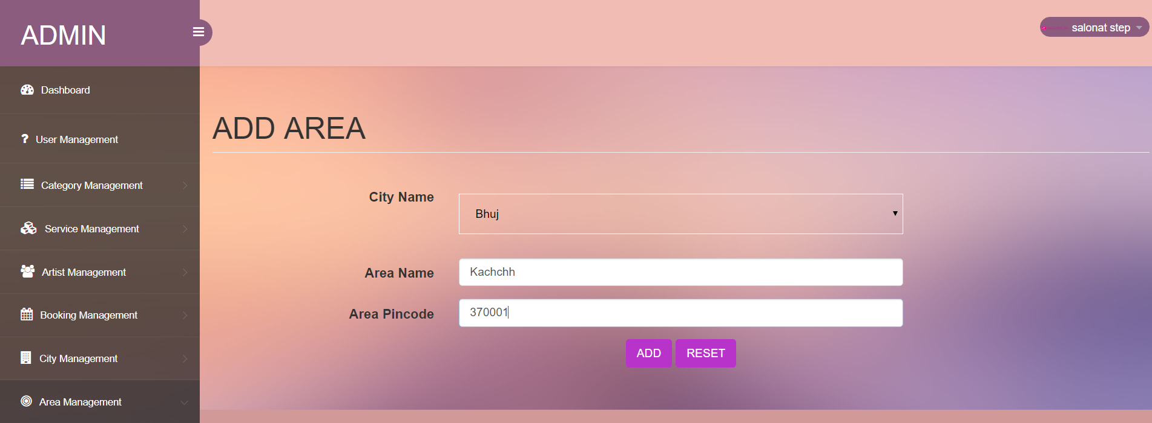

**Output- Manage Area**

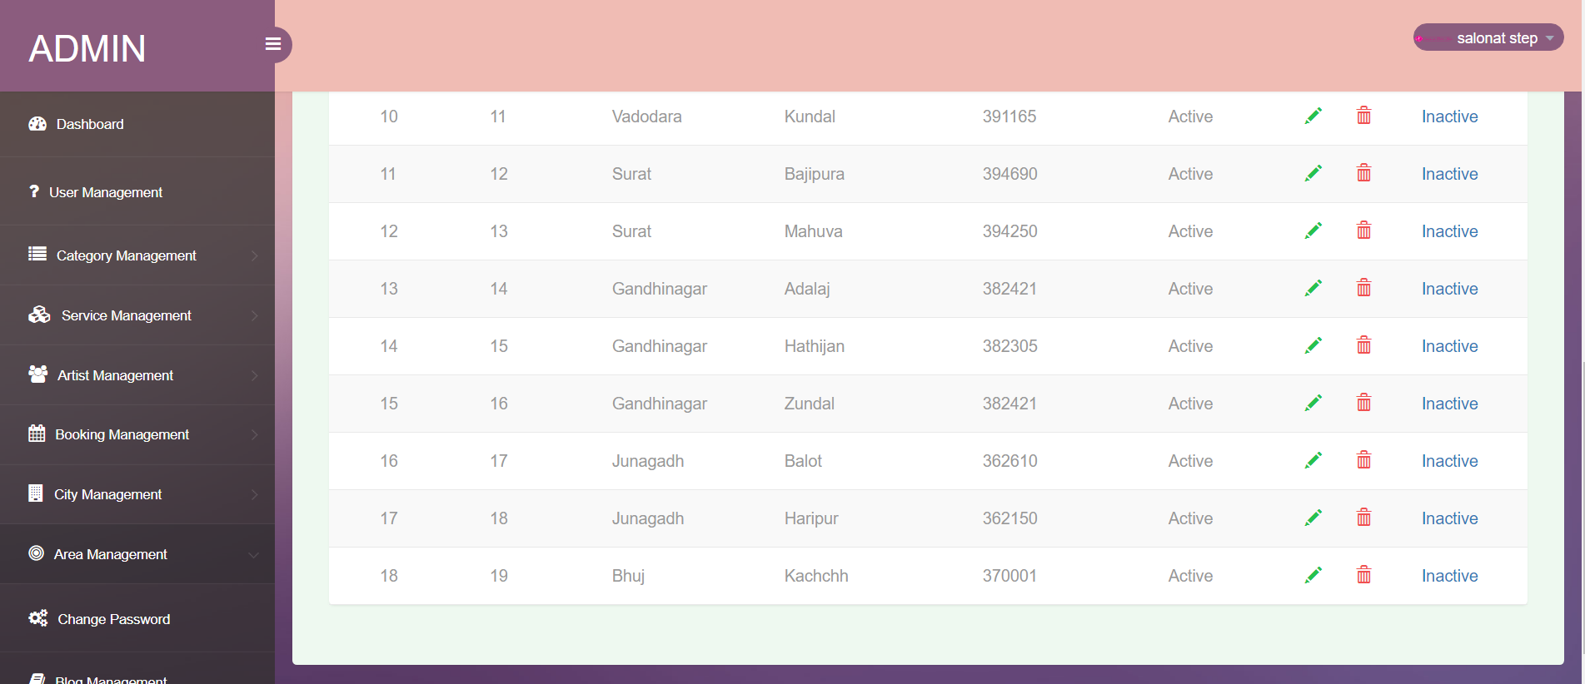

**Input-Add City**

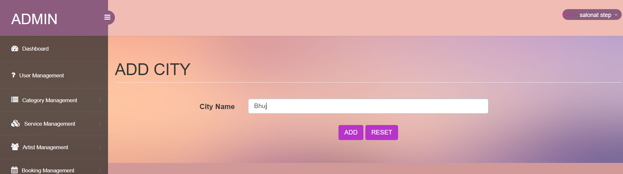

**Output- Manage City**

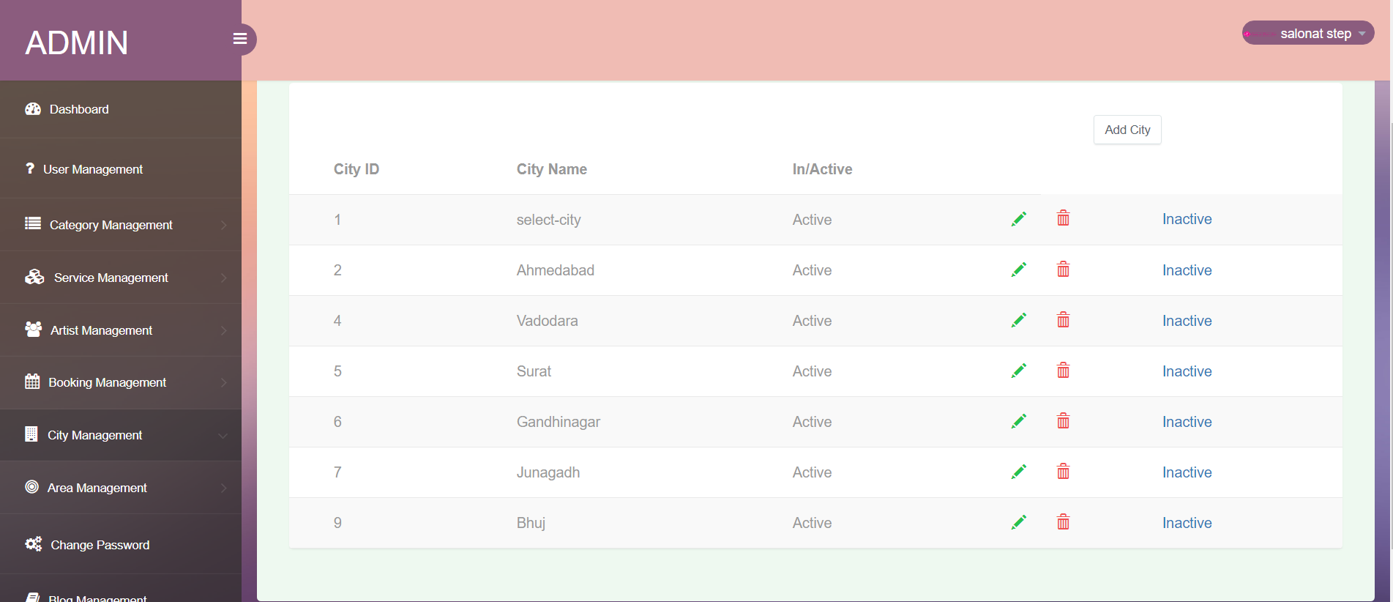

**Input- Add Category**

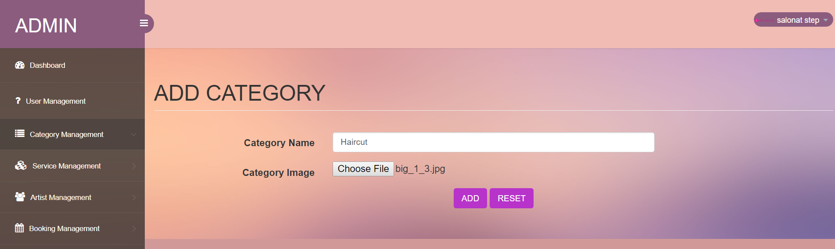

**Output-Manage Category**

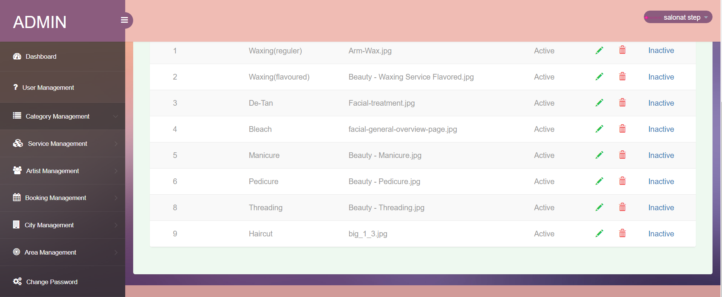

**Input- Add Service**

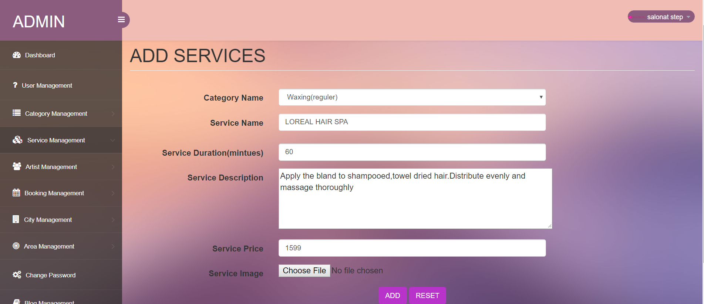

**Output-Manage Service**

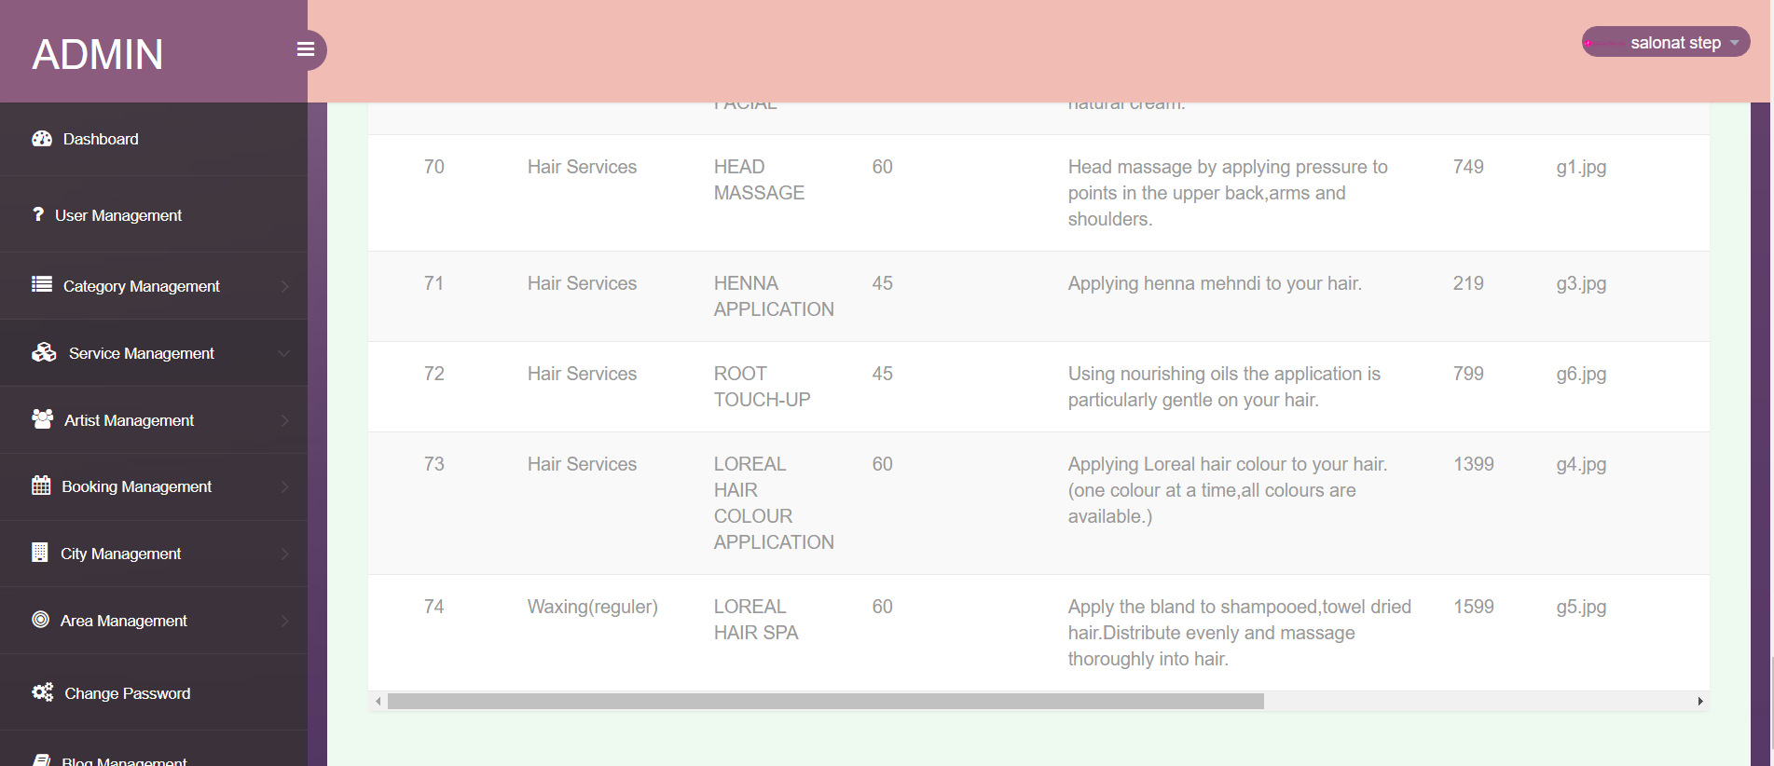

**Input- Add Artist**

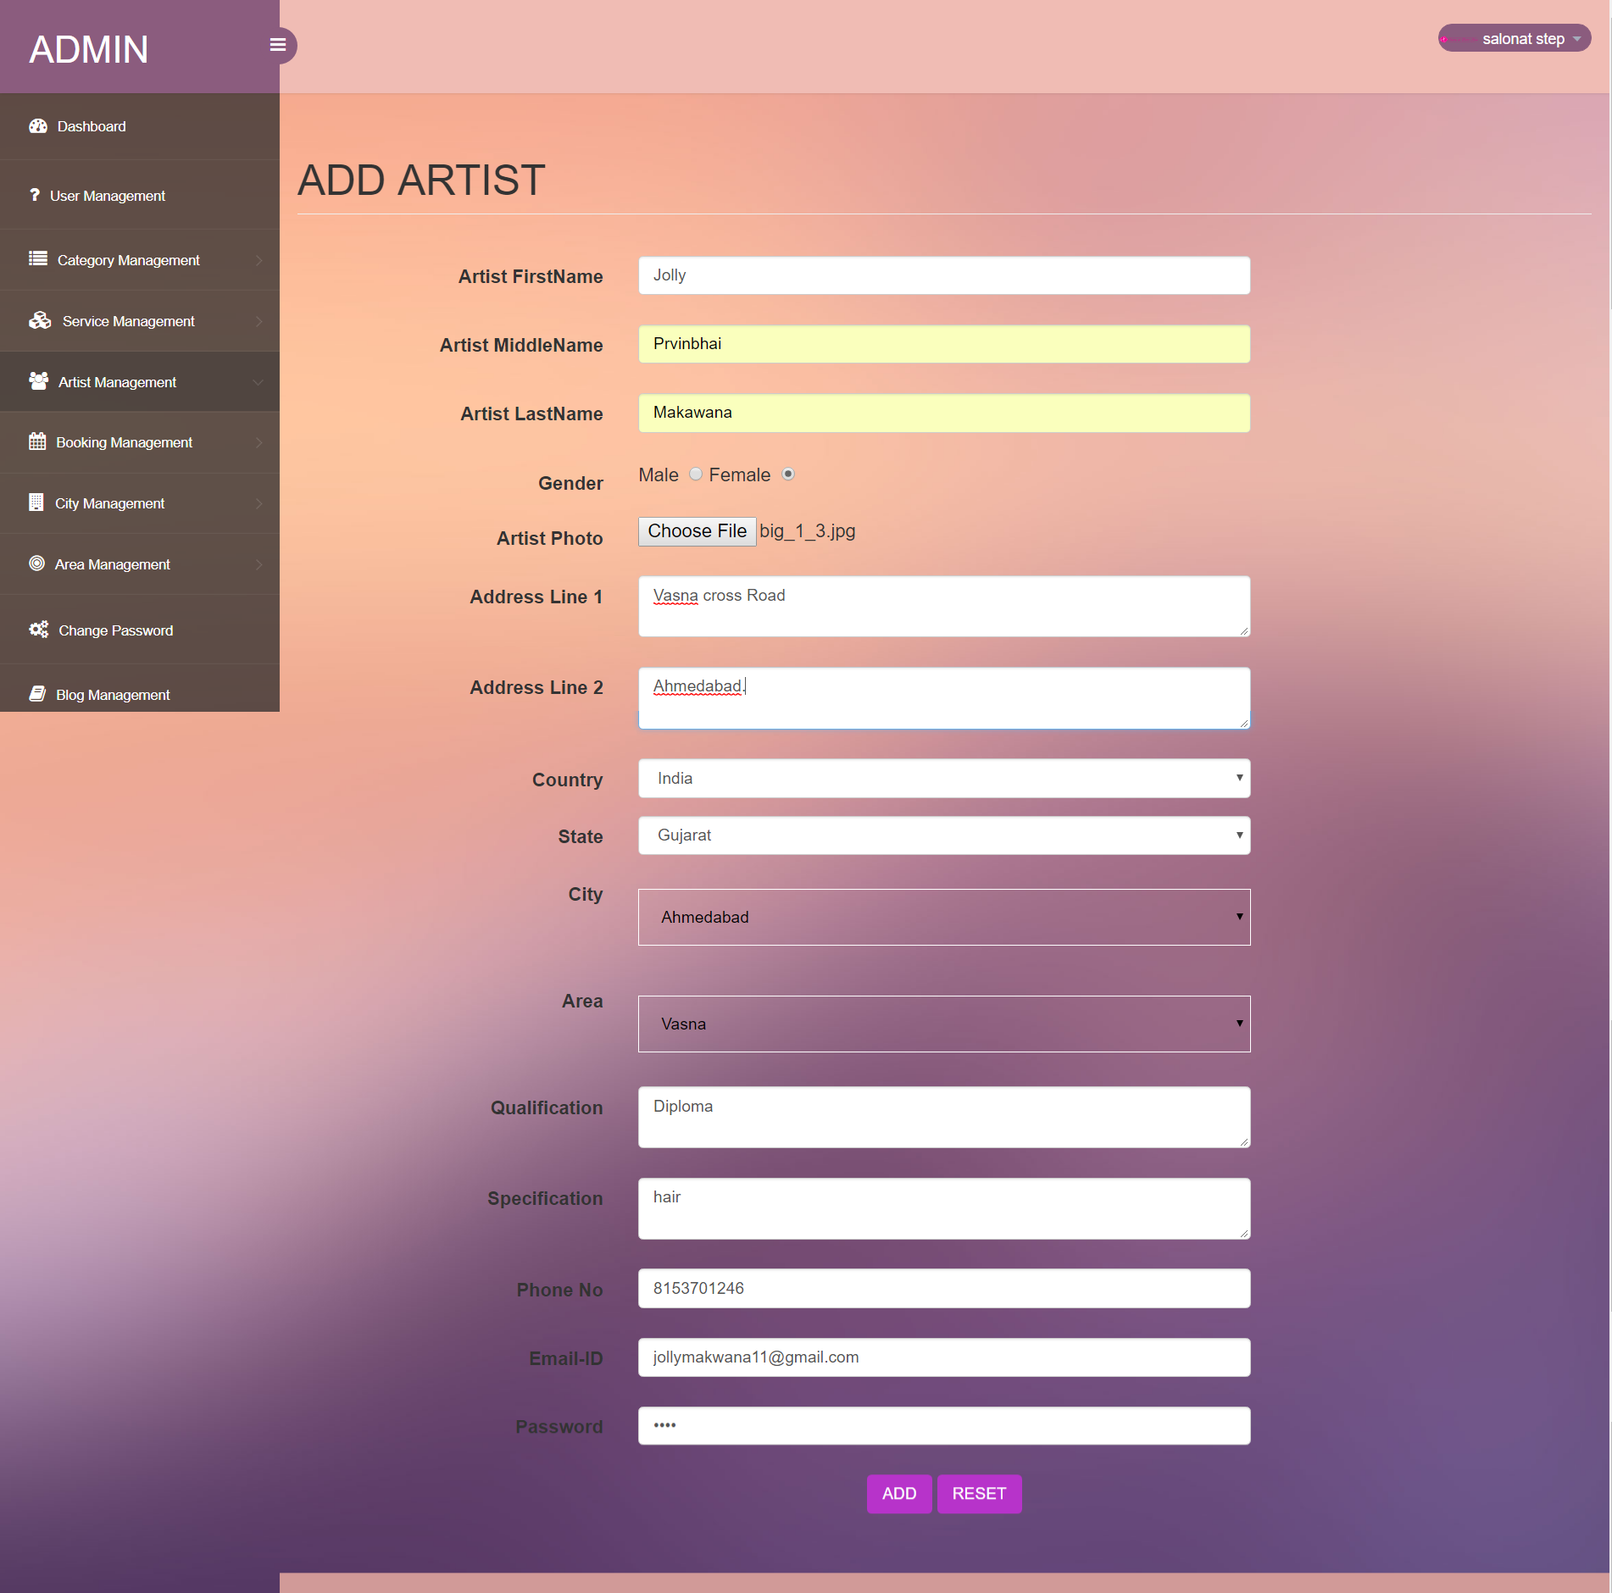

**Output- Manage Artist**

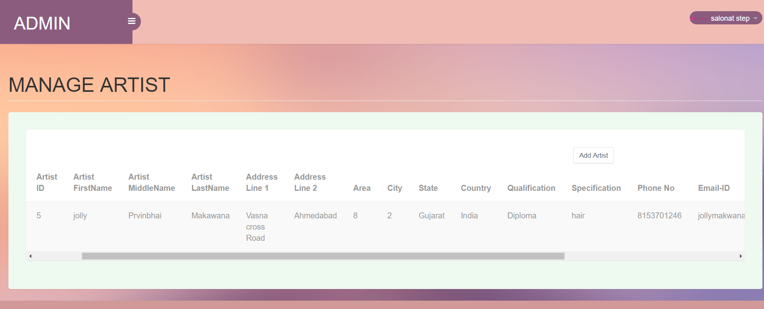

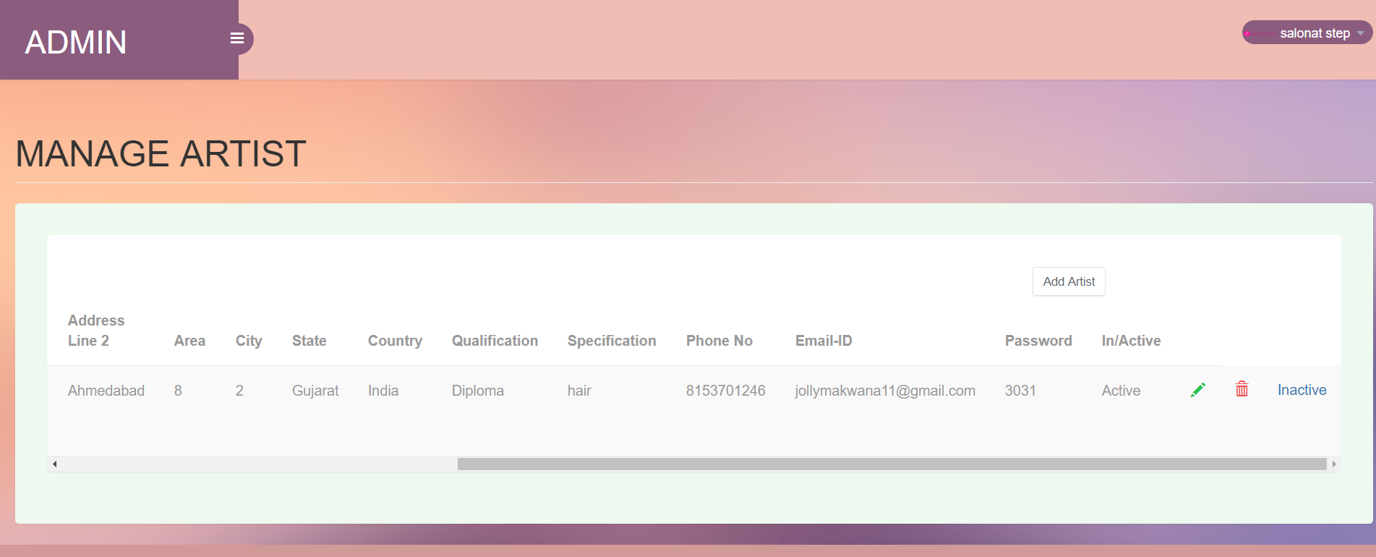

**Input- Edit area**

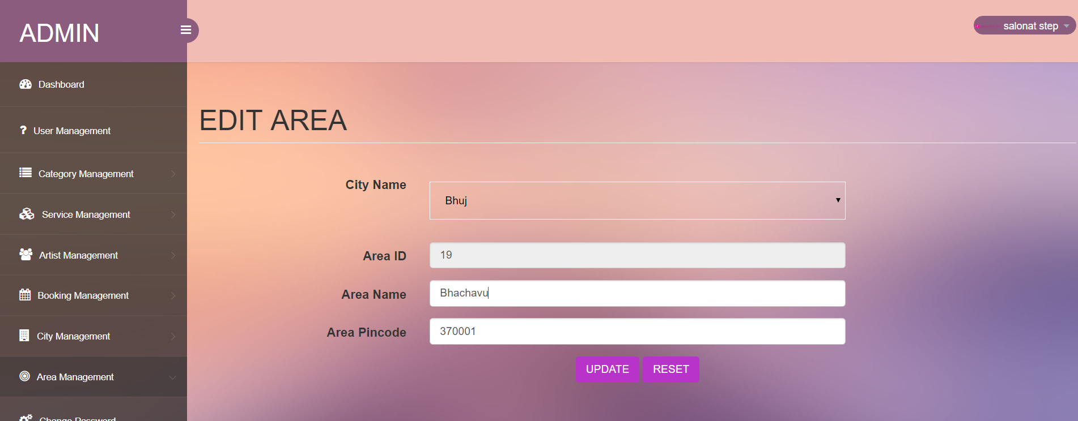

**Output- Manage Area**

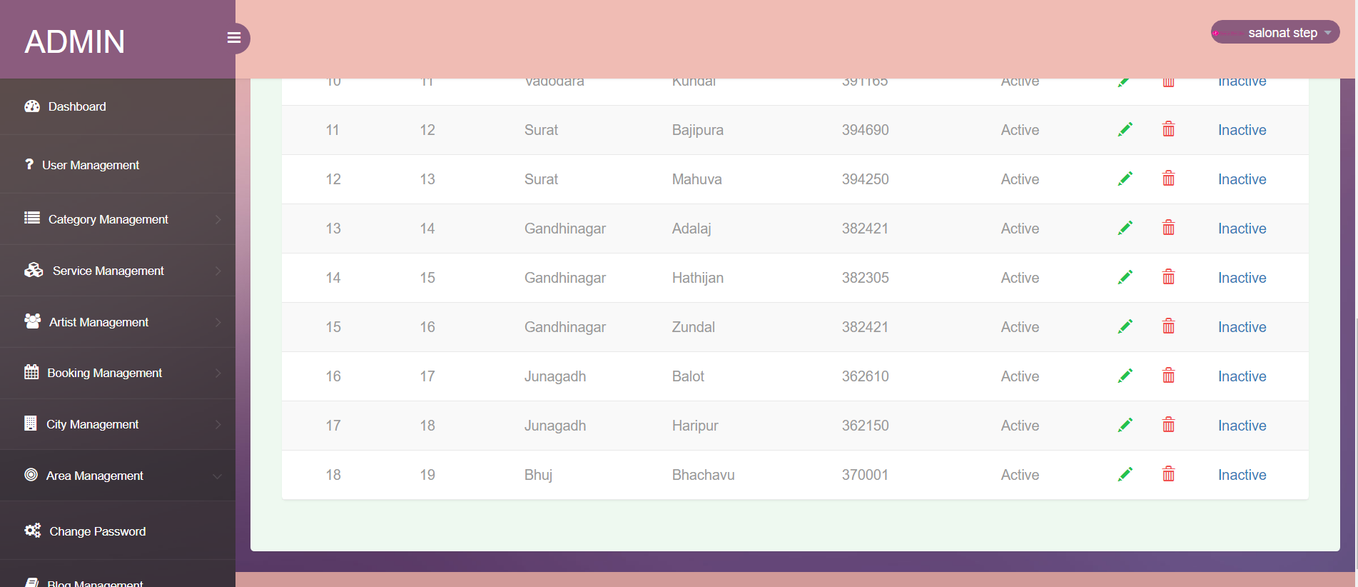

**Input- Blog**

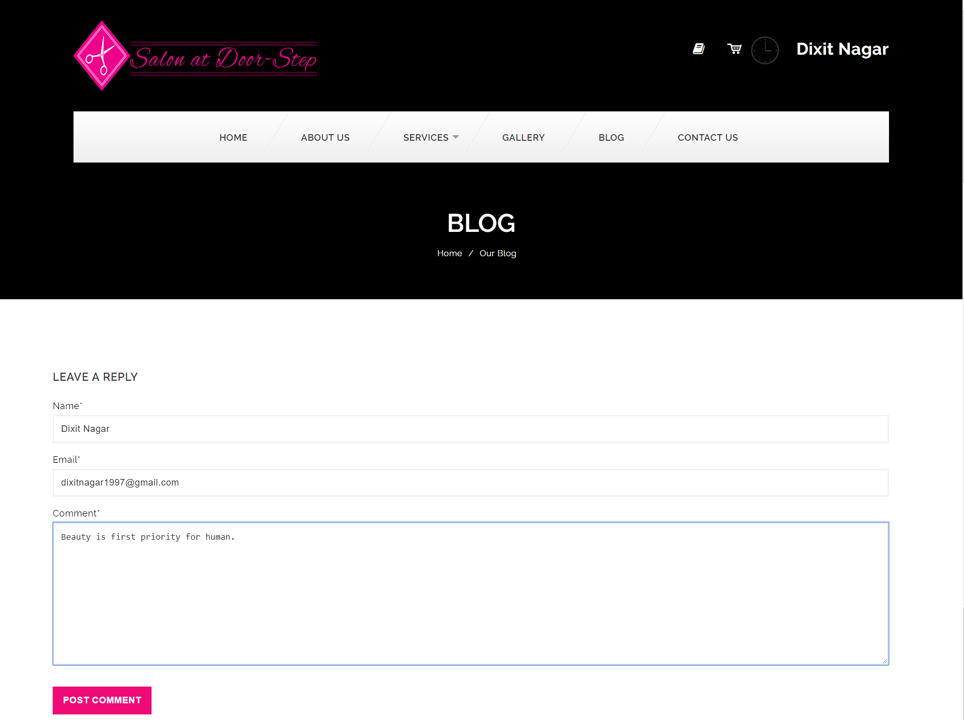

**Output- Blog**

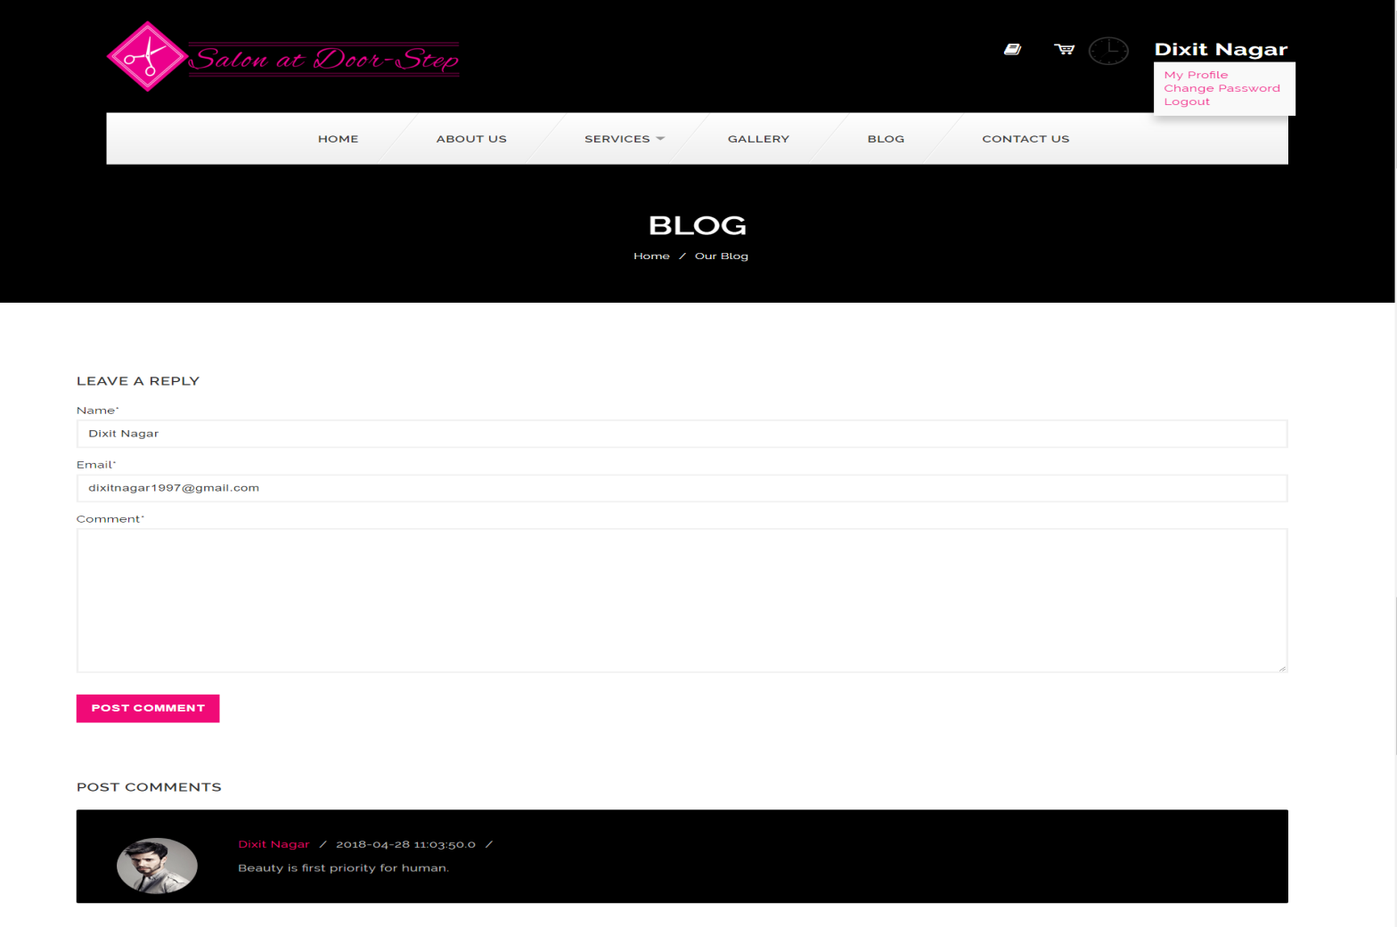

**Input- Complain**

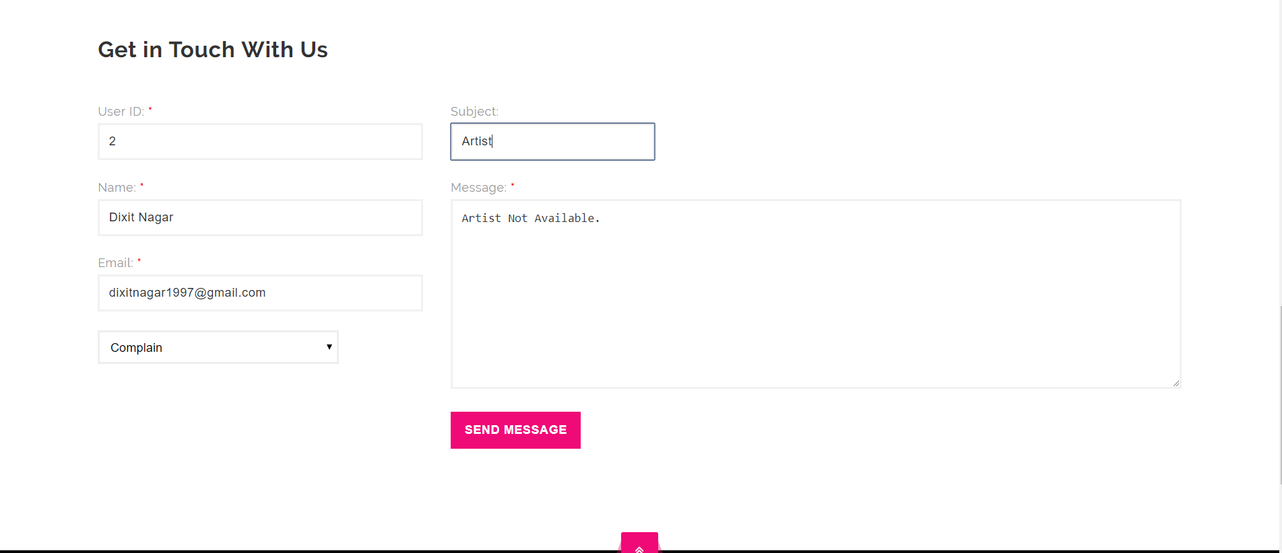

**Output- Manage Complain**

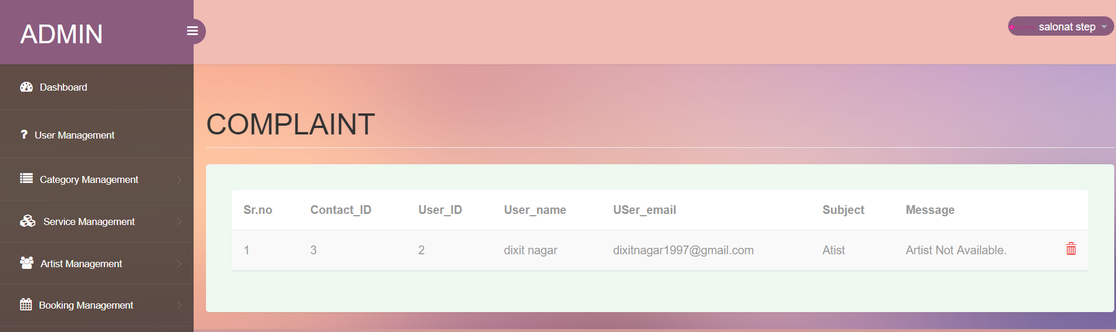

**Input- Feedback**

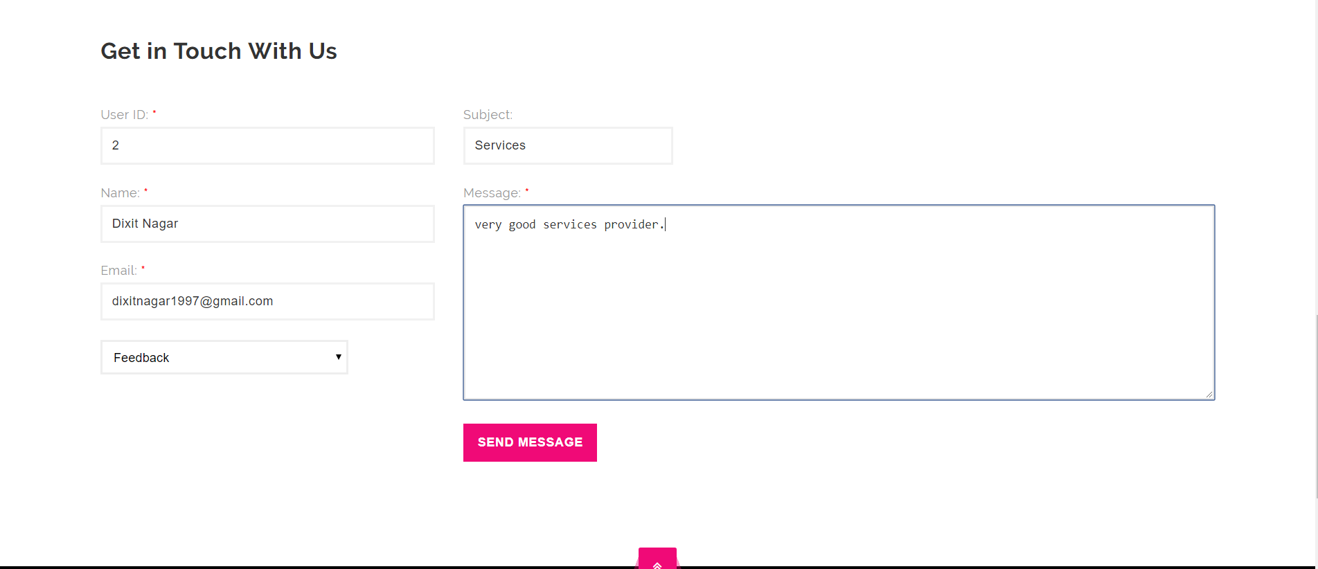

**Output- Manage feedback**

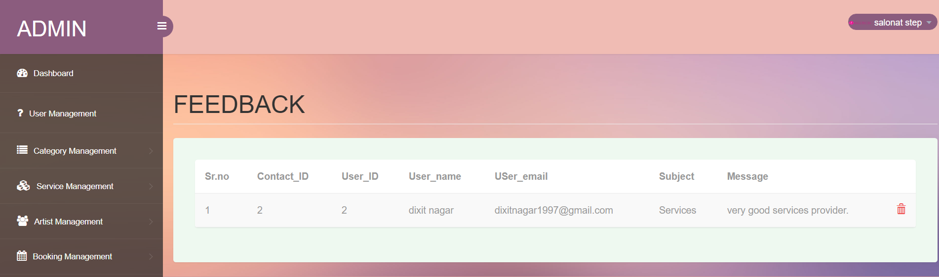

**Input- Cart**

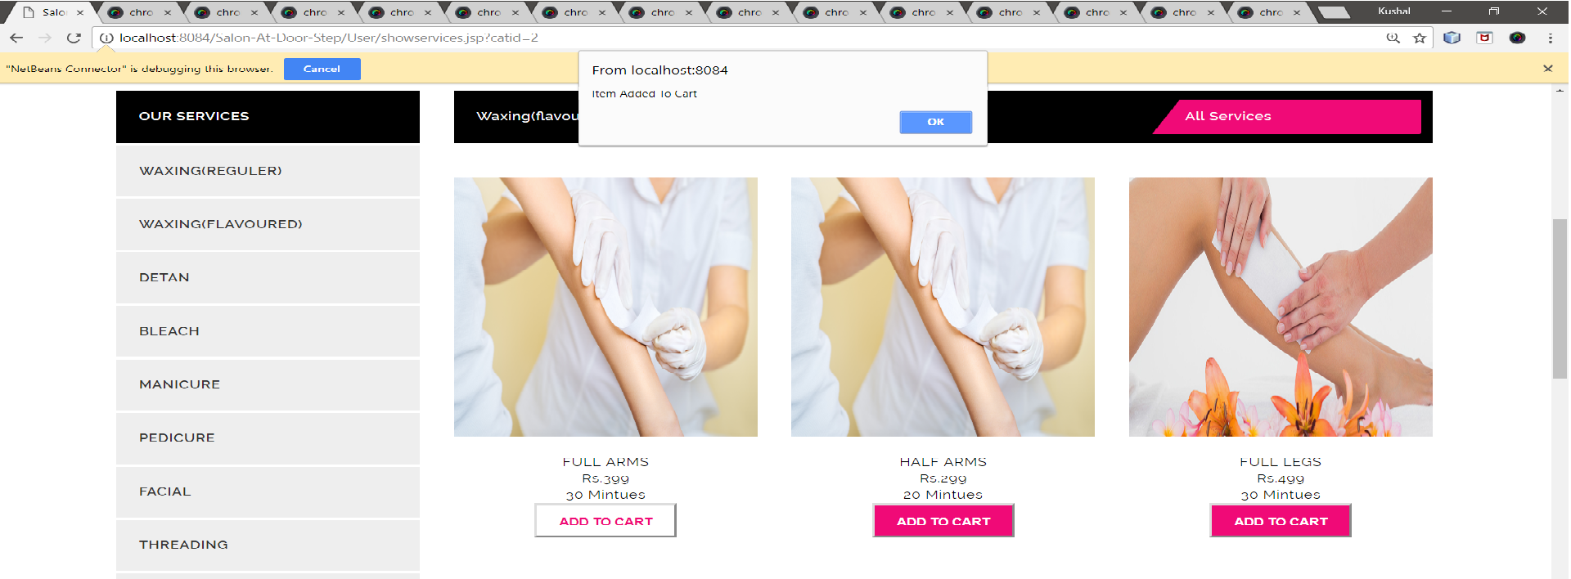

**Output- Cart flow**

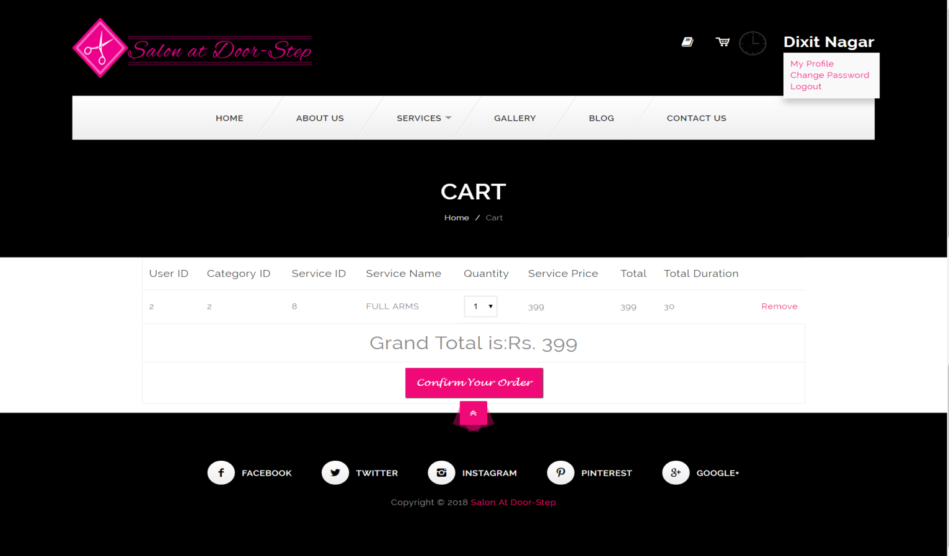

**CH-6 TESTING**

This chapter shows validation and testing of application.

* **Login Page Validation**

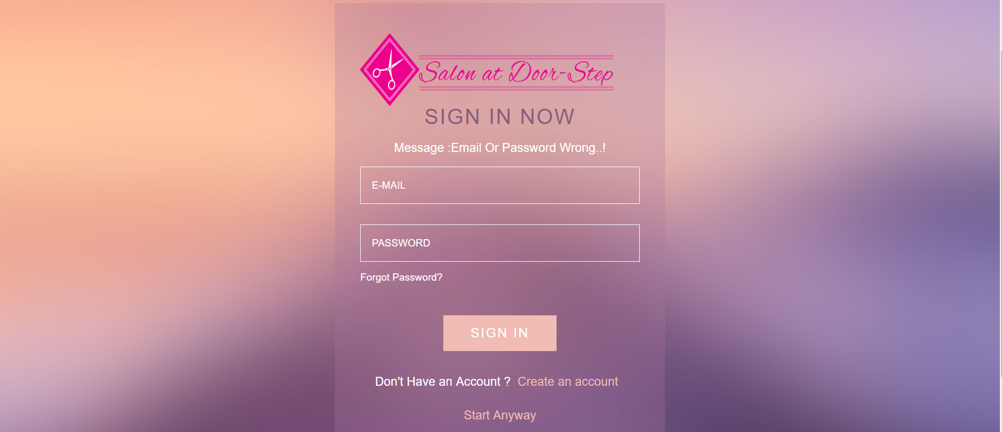

* **Registration form Validation**

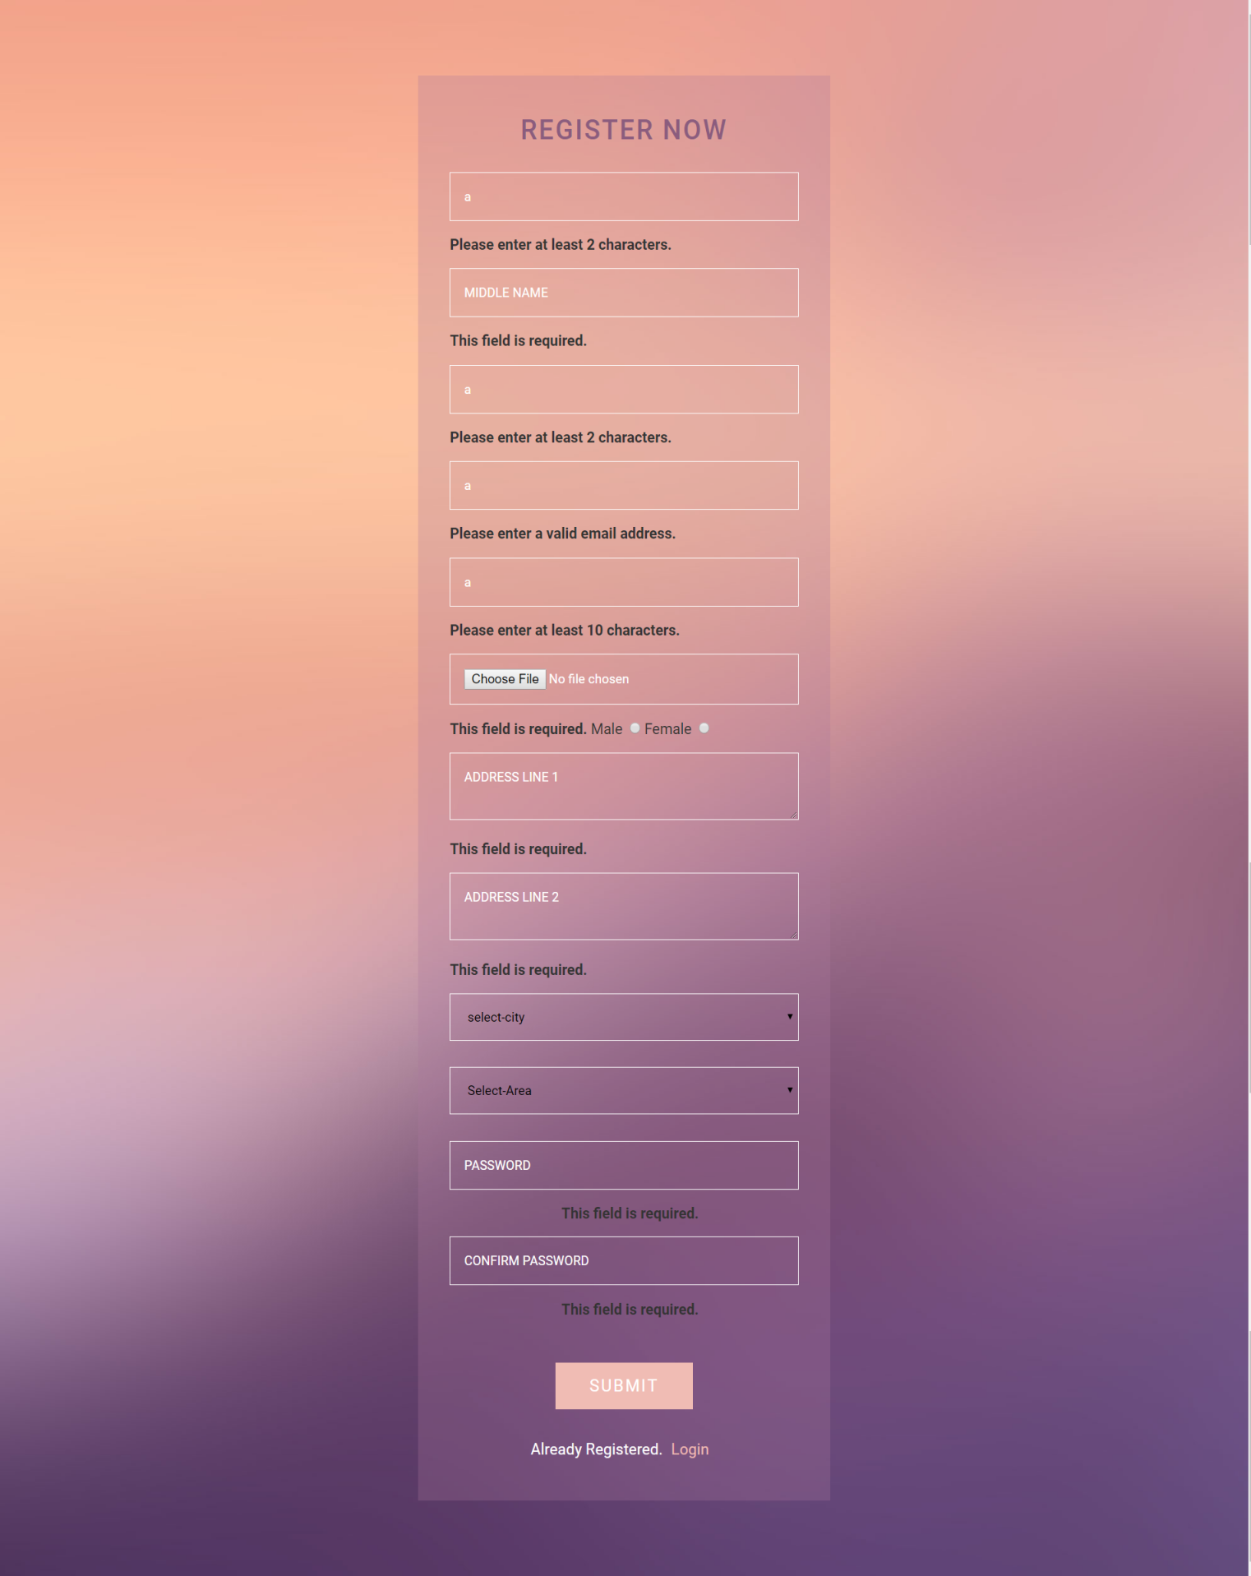

* **Add Area form Validation**

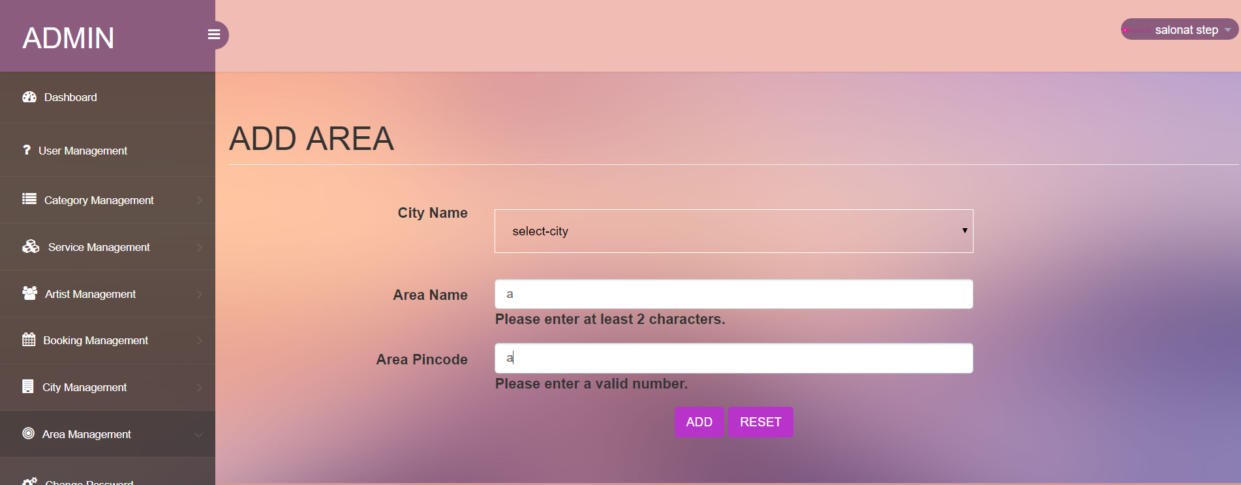

* **Add city form Validation**

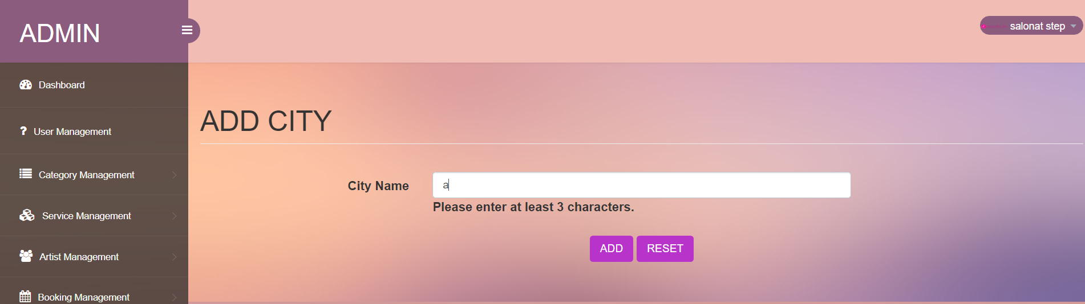

* **Add category form Validation**

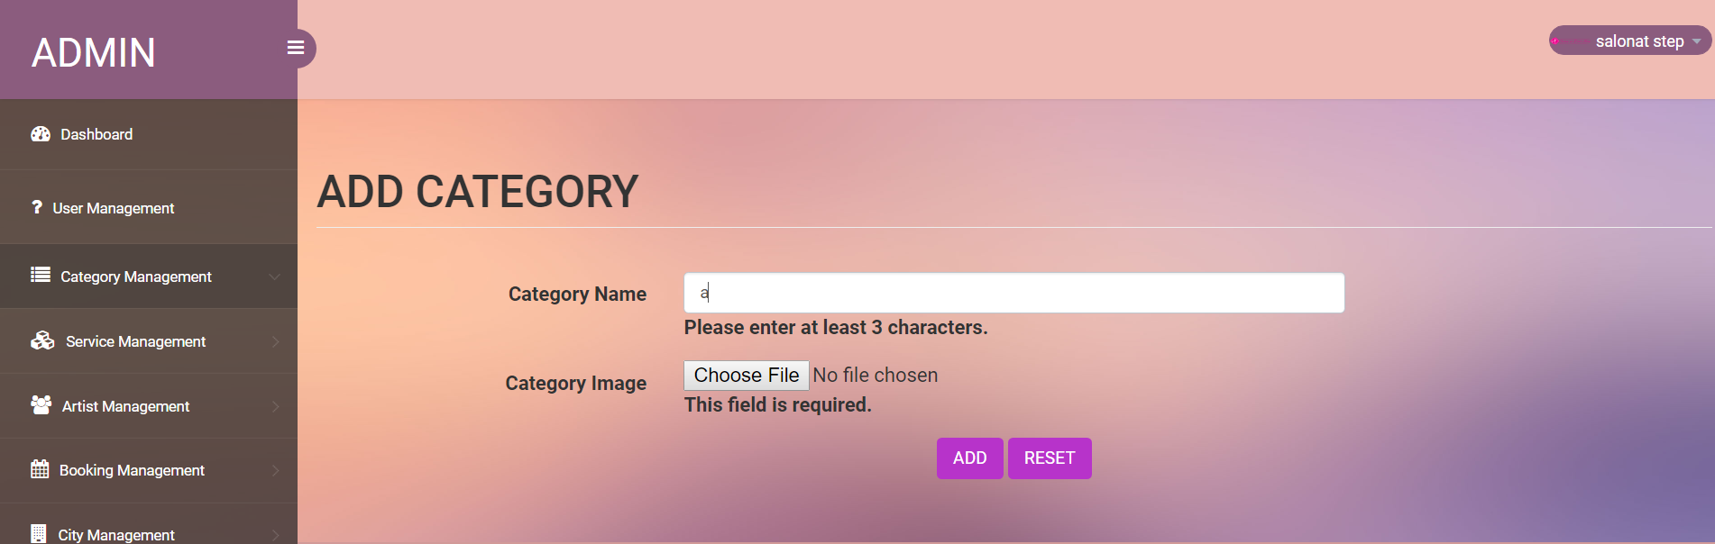

* **Add Services form Validation**

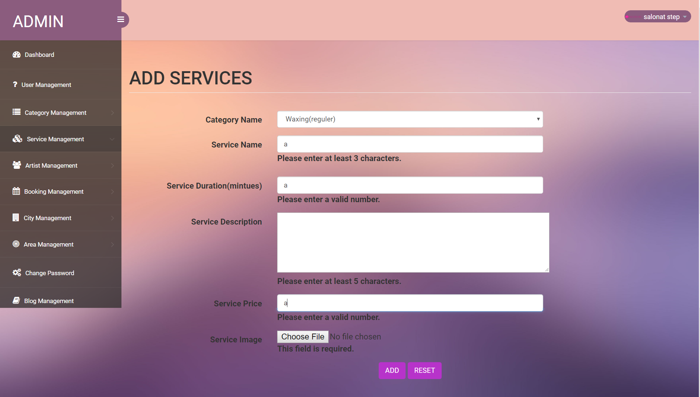

* **Add artist form Validation**

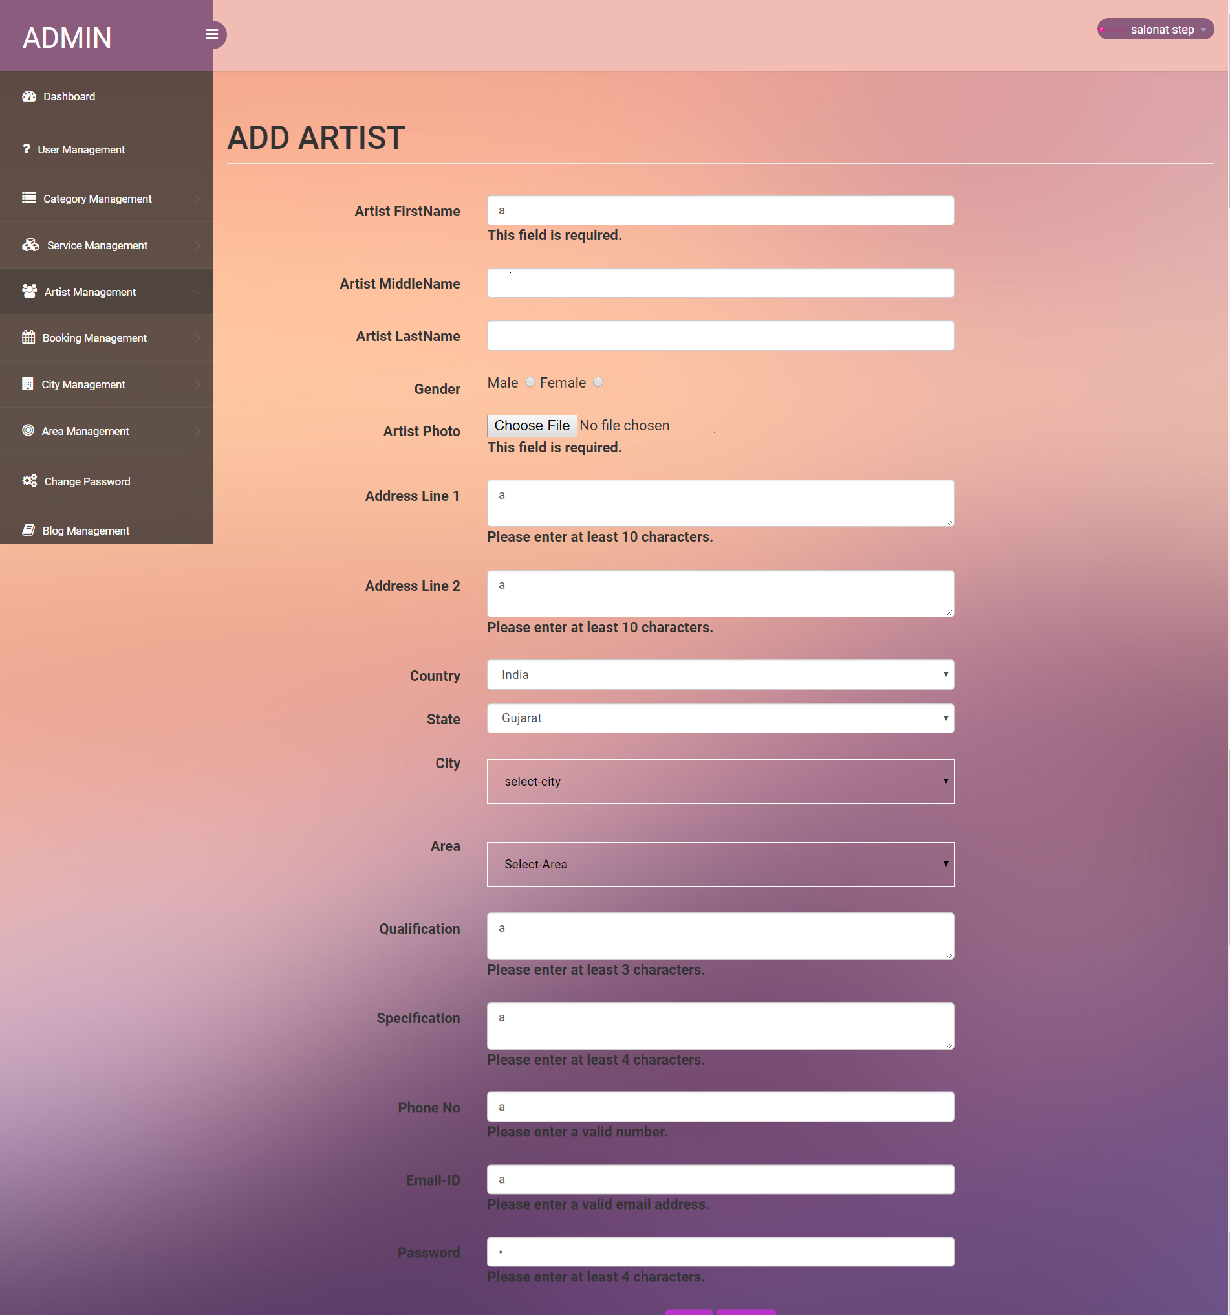

* **Change password form Validation**

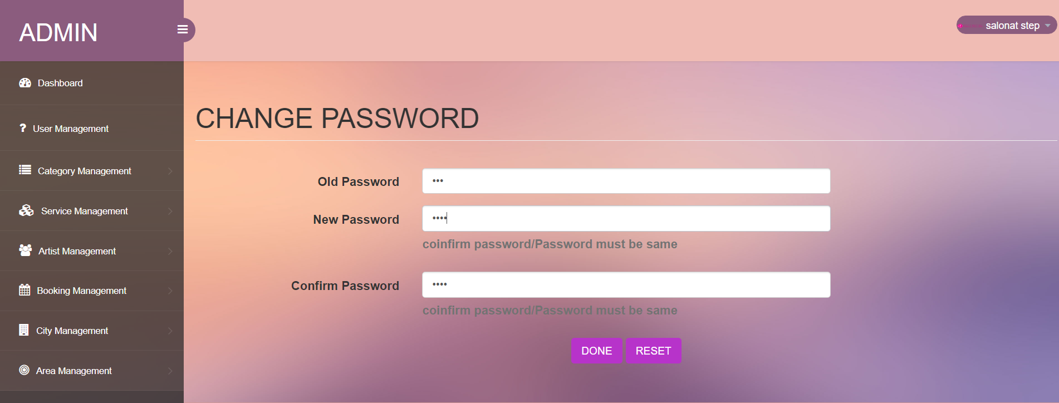

* **Cart Page Validation**

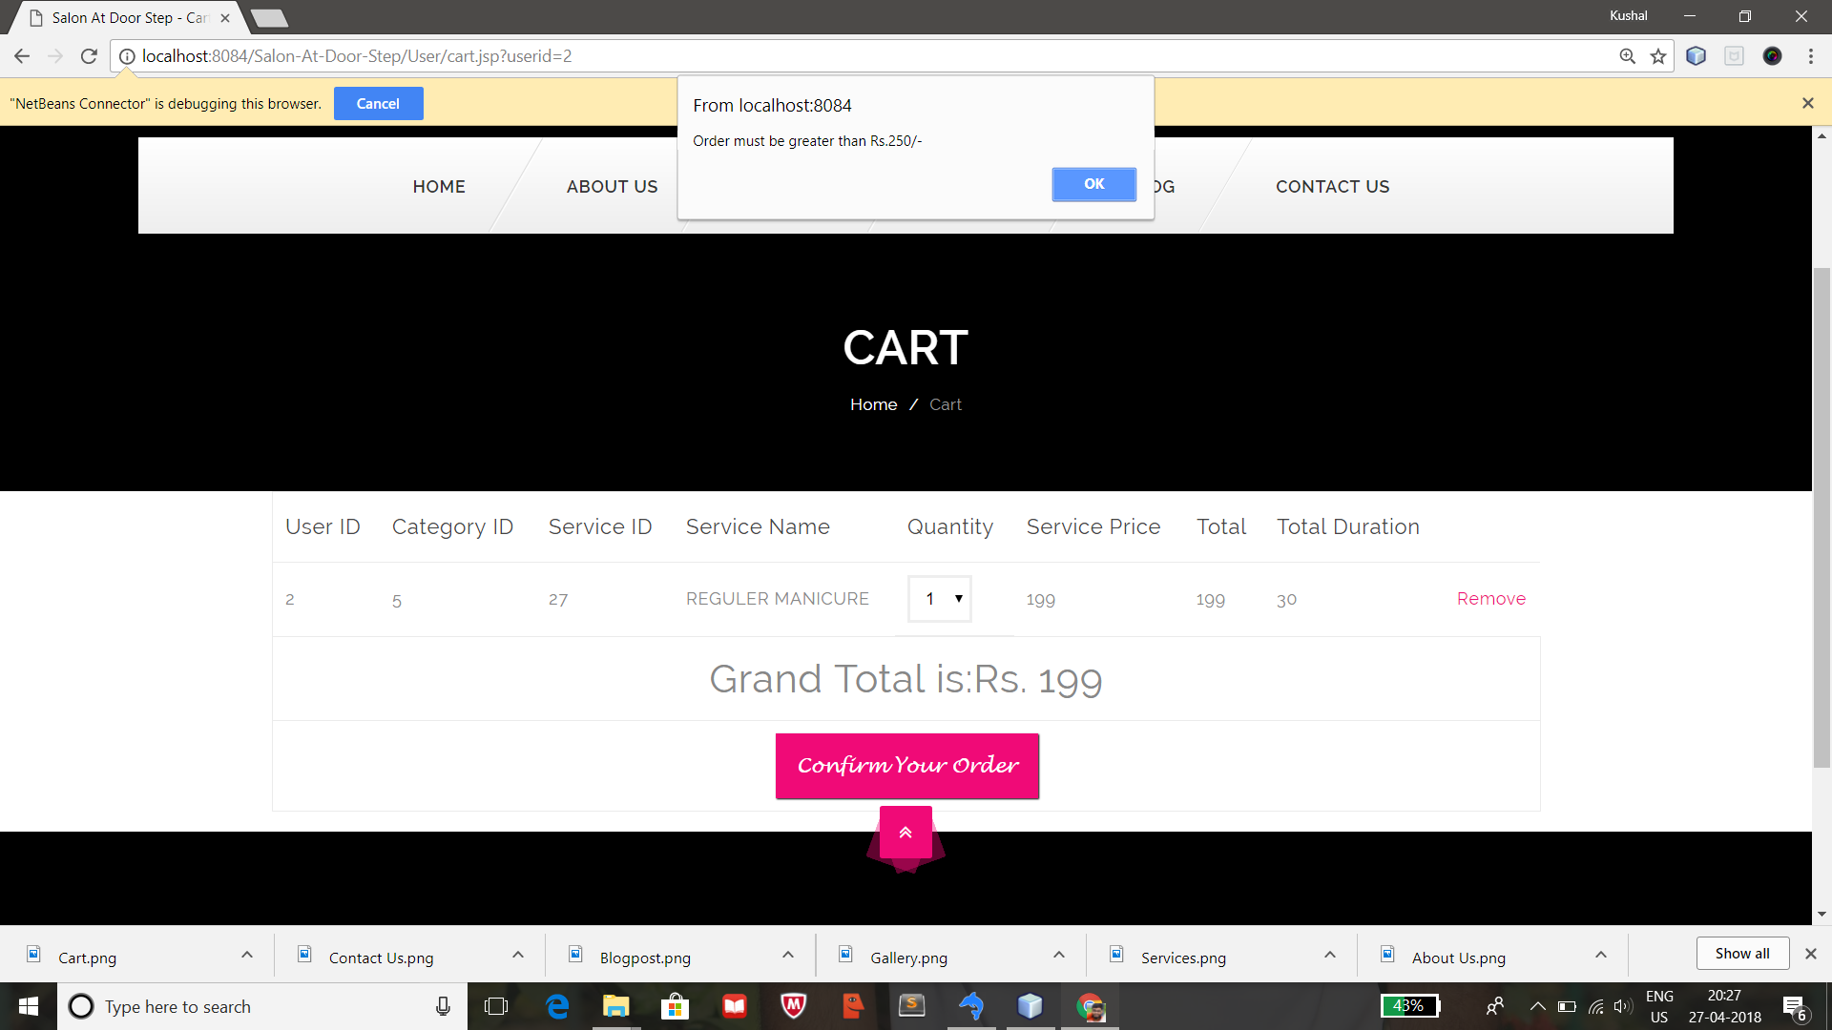

**CH-7 SUMMARY**

This chapter gives summary of the project which includes limitation & future scope of project.

**7.1 LIMITATION**

* Customer must have an internet connection to use this system.
* User must obtain a valid username and password to use this system. If user is not permitted, he/she will not be able to use the functionality of the system.
* It requires large database.
* The admin has to manually manage the inventory section in the system like what items have been used or sold and what items are coming.
* Our system provides service in some particular city.
  1. **FUTURE SCOPE**
* This is system can be easily implemented under various situation, we can add new features as and when we required.
* Customer will rate the artist.
* Admin will manage kit inventory on site.
* Customer will chat with Admin.
* Artist will assign area-wise.
* Online Payment System.
* Artist will upload photos on site.
* Reusability is possible, as and when we require in this system.

**BIBLIOGRAPHY**

**Books:**

* Software Engineering By Roger S. Pressman

**Websites:**

* [www.uml-diagrams.org](http://www.uml-diagrams.org)
* [www.tutorialspoint.com](http://www.tutorialspoint.com)
* [www.lucidchart.com](http://www.lucidchart.com)
* [www.w3school.com](http://www.w3school.com)
* [www.stakeoverflow.com](http://www.stakeoverflow.com)
* [www.javatpoint.com](http://www.javatpoint.com)